What are road surfaces made of, and what causes them to deteriorate?
Most road surfaces are made of asphalt – a mix of stones bound together with bitumen and often called ‘tarmac’.

Tar used to be used for road building many decades ago. Tar is a by-product from the old coal town gas process and has been banned in road and other construction due to health concerns. Almost all bitumen used in asphalt type materials is a derivative from refining oil.

Asphalt is a flexible material, able to flex and stretch, but the bitumen binder becomes brittle as it gets older and cracks appear, typically between ten and twenty years into its life.

Water can get into these cracks and freeze. In poor weather, this ‘freeze-thaw’ effect can lead to a quick deterioration in the asphalt surface and the rapid formation of potholes.

If the deterioration goes too far, the surface may lose integrity and water can get through into the lower layers of the road, damaging them too. For this reason, keeping the surface sealed is key to getting the most life out of a road.

What do we do about this?
We carry out general day-to-day repairs on the road network through our revenue budget – this includes a number of tasks but generally in terms of the road surface means fixing potholes, carrying out small patch repairs and sealing the road surface using jetpatcher machines

We have a detailed assessment and repair criteria which is used by all roads authorities in the west of Scotland for road safety inspections and defect categorisation, and the repair timescales for different issues are set out in our roads asset management plan.

Generally most of our potholes fall into a 30day repair timeframe.

Both of these important documents are available here.

We then model different options for capital investment in our Annual Status and Options Report, which sets out different investment options and allows Members to make informed decisions about capital funding for road improvements.

When capital funding is allocated for road improvements, what happens next?
First, we consider the Road Condition Index [RCI]
Automated road condition surveys provide a consistent method of measuring the surface condition of all 32 Scottish Councils’ road network.
The road condition survey is carried out annually as follows;
100% of the A Class roads are surveyed in one direction
50% of the B Class roads
25% of the C Class roads
10% of the unclassified road network
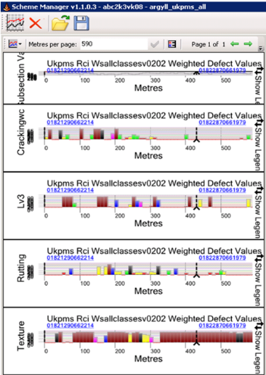
A range of road condition parameters are measured including ride quality, rut depth, cracking, texture depth and edge condition. The survey uses a vehicle mounted scanner which reads over 30 different attributes of the road, similar to a supermarket barcode scanner.
Through a computer software package the scanned data gives a score called the Road Condition Index [RCI].
The RCI gives a baseline position for our roads.
Thanks to prudent investment and proportionate engineering treatments [more detail on these below], Argyll and Bute’s road network RCI has steadily improved in recent years. As well as this information being the basis for building programmes of work, Audit Scotland use the RCI for monitoring performance across all Councils.
Secondly, we consider the results of the Sideway-force Coefficient Routine Investigation Machine [SCRIM] survey.
This measures the skid-resistance of our A class mainland strategic road network.
We then use a system called Scheme Manager which is part of our asset management system held in WDM [this is the acronym of the company who provided the system] to produce a first draft list of schemes to the available capital funding. A weighting is applied to the road hierarchy to help prioritise schemes on busier roads.
The first draft is then circulated throughout our team of area-based roads engineers. Sometimes the survey information is not representative of the most recent deterioration so Officer advice at that stage is one of a number of key inputs – this advice is based on visual inspections, collision data, representations from Members, the public etc., known utility company programmes of work, opportunities for external investment/contributions etc.

The draft scheme list is then revised and further discussions take place to consider the surface treatment proposals, any alternative options, the budget estimates and any site collision history.

Other factors considered include:
- Potential impact from Forestry Operations,
- Potential for supplementary funding (e.g. Forestry),
- Hybrid scheme requirements (e.g. to include drainage repairs, road signing improvements etc.),
- Utility company works and warranty issues impacting programme or delivery,
- Environmental, flooding, geotechnical issues,
- Local Community initiatives or priorities,
- Impact of proposed schemes on local economy (e.g. tourism, ports).
The draft scheme list is then updated as required to take account of the above.
This is then presented to the Environment, Development and Infrastructure Committee for Member endorsement in March each year following the budget process and allocation of funding. Dependent on winter deterioration there may be the need for minor adjustment to the programme to ensure that the sections of road which will provide the best rate of return are treated.
The Council’s Audit and Scrutiny Committee in 2019 considered a report on Road Resurfacing, in which the Panel concluded that the Council has a robust approach to scheme development which utilises an appropriate balance of data and professional judgement to create a programme of works. The Panel took evidence from a number of different external bodies to reach its conclusion.
Potholes are formed by water, freezing and freeze-thaw cycles, excessive heat, wear and tear – and time.
Local road network in Argyll and Bute

- A class roads 505km
- B class roads 613km
- C class roads 434km
- Unclassified roads 733km
- 866km [38%] on islands; 1420km mainland
- 24% constructed on peat

What type of carriageway treatments are used to maintain the road network?

Carriageway maintenance treatments can be grouped in to three broad categories.

• Surface Treatments
• Resurfacing
• Recycling/Reconstruction

Each has a different range of benefits and costs and some are only appropriate under certain circumstances.

Surface treatments

Surface treatments include surface dressing and thin surfacing such as micro asphalts. These all involve laying a thin layer over the top of the existing road to seal the surface and restore grip, extending the life of the road. They will also rectify surface defects like cracks and potholes, either as part of the treatment process or through pre-patching works done to the more significant defects in advance of the surface treatment.

Resurfacing

Resurfacing usually involves removing and replacing the existing road surface (although it is sometimes possible to lay the new surface on top of the old). Resurfacing differs from a surface treatment by using a thicker layer of material; usually at least 30mm thick and sometimes 100mm or more if several layers of the road are replaced. Resurfacing restores the road surface to a new condition, removing surface problems, most unevenness and can add structural strength to the road

Recycling/reconstruction

Reconstruction involves digging down to repair or replace some or all of the foundation layers of the road and then putting a new surface back on top. Limited areas of reconstruction are sometimes used to solve localised problems as part of a resurfacing scheme.

In a number of situations a geotextile material will be sandwiched between the surfacing layers to provide additional strength and to help to reduce surface cracking.

Which treatment to choose?
The different treatments offer a different range of benefits.

Selecting the right treatment for a particular road will depend on many things including the condition and construction of the road and the amount and type of traffic it takes, as well as the available funding and the life cycle being designed for.

The table below summarises some of the main factors to consider but each situation is unique and each road needs to be considered on its own individual merits.

 | Surface  Treatment | Resurfacing | Reconstruction
Seals the surface | Yes | Yes | Yes
Restores grip | Yes | Yes | Yes
Extends road life | Yes | Yes | Yes
Repairs surface defects | Yes | Yes | Yes
Removes minor dips | Sometimes | Yes | Yes
Removes major unevenness | No | Sometimes | Yes
Adds strength | No | Sometimes | Yes
Repairs foundation problems | No | No | Yes
Cost | Low | Medium | High
Environmental impact | Low | Medium | Medium/High
Disruption | Low | Medium | High

The below graph gives indicative cost comparisons of different treatment types:
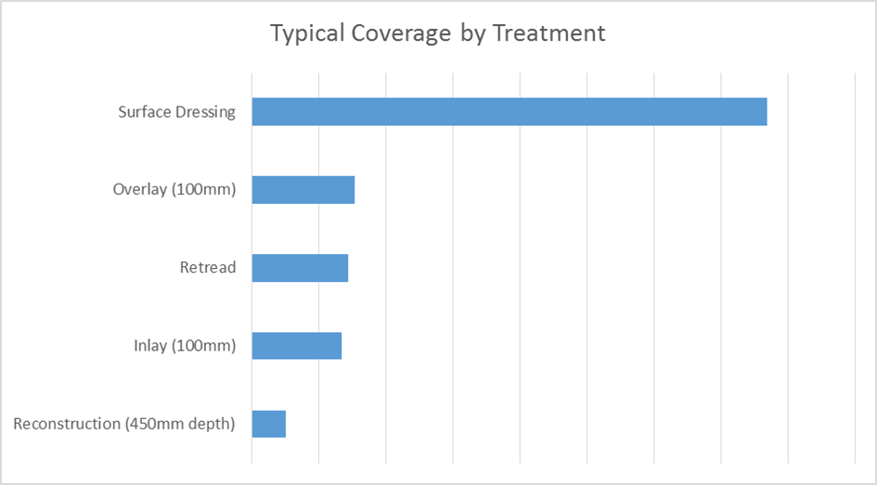

Surface treatments
Surface dressing
For information on surface dressing, please see our separate surface dressing information sheet.

Thin surfacing

Also known as: micro surfacing, ‘micro’, slurry seal (more commonly used on footways but useful in some carriageway situations).

Advantages:
- Relatively low cost
- Seals the surface and extends road life
- Restores texture and grip
- Quick to apply meaning less disruption
- Lower carbon footprint than resurfacing
- Removes minor dips and fills potholes to improve ride quality

Disadvantages:
- Does not remove major unevenness or deal with significant structural defects
- Loose stones will remain on the road surface for some weeks after laying
- Not suitable for very high stress sites.

The process
Before: any major defects are repaired ahead of time. Minor defects like cracks and surface potholes can usually be filled by the treatment without additional work.
On the day: the road is swept to clean it and remove debris and then the micro asphalt is laid over the existing road surface. It is usually laid in two coats; the first helps to fill defects and regulate out dips in the road surface; the second provides the new road surface. The material will stay relatively soft for several weeks after laying so not all roads are suitable for this treatment. Manhole covers and drains are adjusted to suit the new road level which will be about 15mm higher than the old road due to the thickness of the micro asphalt.
Resurfacing
Also known as: surfacing, plane & inlay, inlay, overlay.
Advantages:
- Replaces the surface
- Restores texture and grip
- Extends road life
- Restores ride quality
- Relatively fast operation
Disadvantages:
- Does not fix deep problems with the foundations
- Can be expensive, especially if several layers need replacing
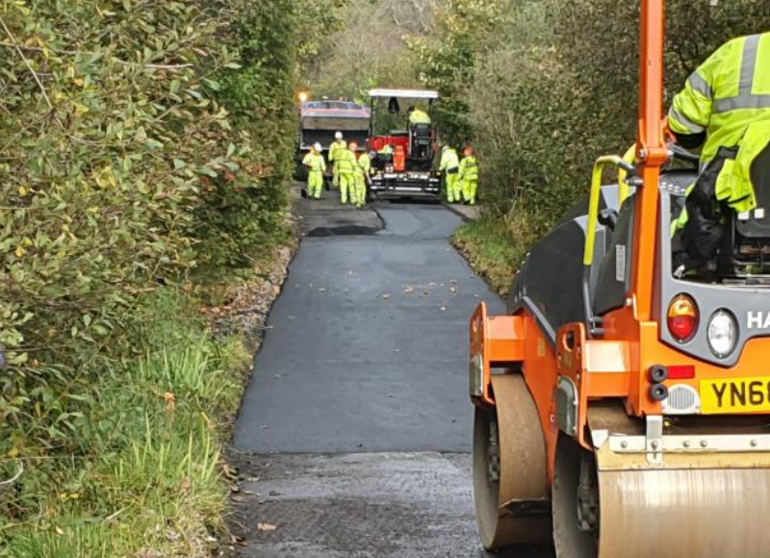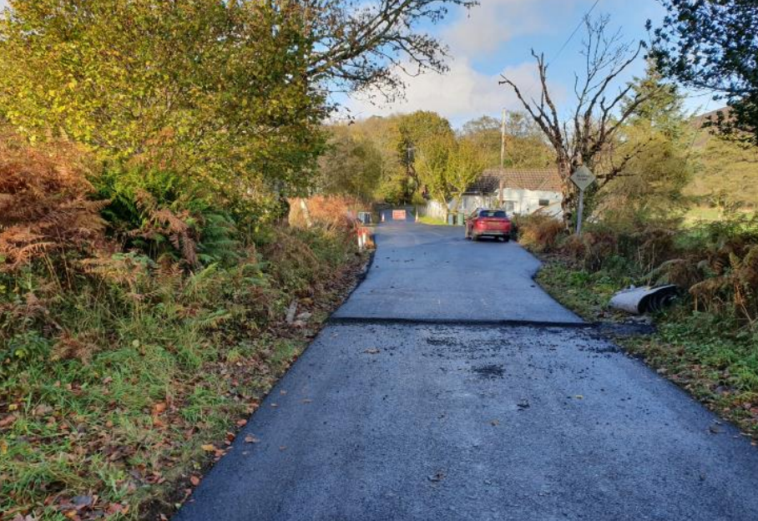

The process
Preparation: the old road surface is removed by a process known as ‘planing’ where a large machine with a rotating drum covered in teeth chews off the old surface.
Laying: the new asphalt or bitmac is laid at a high temperature and so is brought to site in insulated lorries. Once there it is fed into a paving machine which lays a controlled thickness of the chosen material, this is then rolled to compact it and give an even surface.
Recycling
Also known as: re-tread, shallow in-situ recycling.
Advantages:
- Replaces the surface
- Restores texture and grip
- Extends road life
- Restores ride quality
- Creates or restores the structural layers of quieter roads
Disadvantages:
- Expensive compared to other operations
- Multi-stage operation (disruption lasts longer)
Where would we use this?

This option only goes down perhaps 75 to 100mm and existing material is recycled on site, not taken away.
This will not fix structural problems on main roads, since they are thicker than this, but many of Argyll and Bute’s older roads have only a thin asphalt/bitmac surface on them. In these cases re-tread offers an option to renew (or create) a structural layer on which the new surface can be laid. For that reason, it is usually used on quieter roads where no other treatment is suitable.

Reconstruction
Reconstruction is a very expensive treatment but, fortunately, most roads will not need full reconstruction in a normal life cycle – resurfacing and surface treatment is usually enough. There are a few exceptions to the rule:
- Roads with too little structure to resurface – we tend to use retreat (see recycling)
- Roads with underlying problems – these problems are usually localised and we can used limited reconstruction along with general resurfacing.
- Partial reconstruction / Edge Widening is a more common improvement, where existing carriageways are too narrow for modern vehicles to pass safely.
- Existing carriageways are widened by excavating or filling, in existing verges and constructing a strip foundation to the existing carriageway. This is then overlayed to the new running width, to increase the overall strength of the road to resist the passage of Heavy Goods Vehicles and improve journey times for all users.
Advantages:
- Replaces the surface
- Restores texture and grip
- Extends road life
- Creates or restores the structural layers of the road
Disadvantages:
- Very expensive compares to other options
- Lengthy operation so very expensive.

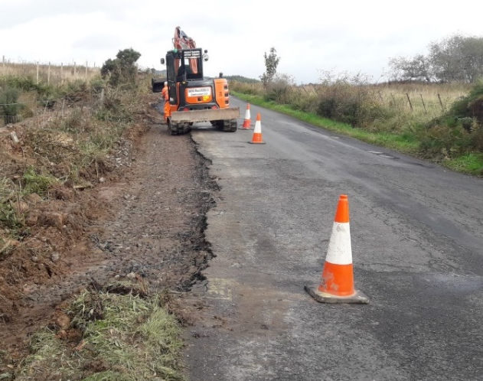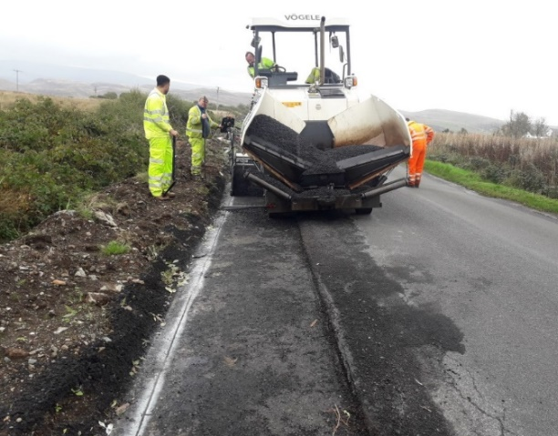
These images show edge strengthening/part width reconstruction being carried out

Summary of surface treatment types carried out last year
Surface Treatment | Percentage
Surface Dressing | 30
Thin/Micro Surfacing | 1
Thin Overlay | 30
Moderate Overlay | 1
Structural Overlay | 2
Thin Inlay | 17
Moderate Inlay | 8
Structural Inlay | 3
Reconstruction | 8

