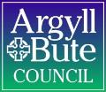

Member Zone: Member Update Briefing 2 (July 2022)

- INTRODUCTION
It is now two months since the launch of Member Zone and in that time 319 requests have been logged by 27 different members. 248 (78%) of those were for Roads and Infrastructure Services with 71 for other Services. As the development of Member Zone enters in to phase 2, the following new features / updates will be made live on Tuesday 9th August:
- A new escalation process to ensure contentious requests are resolved (point 2 below)
- A way to log non-Council enquiries so MZ can hold all member enquiries (point 3 below)
- A link to the corporate organisation chart added to Enquiry Type page (point 4 below)
The purpose of this briefing is to advise Members of the three new features that will be made live after the Elected Members Seminar.
There are a number of other developments in progress and these will be outlined to Members during the online Elected Members Seminar on the 9th of August.
- ESCALATION OF ENQUIRIES

  - Overview of Escalation Process
Although every best effort will be made by Services to provide full and timely responses to the satisfaction of members, there may be situations where a member feels the response is taking too long or does not adequately address the matters raised. In the old Councillor Casebook system this could sometimes result in requests being stuck in limbo as members were unwilling to close them and the Service respondent thought they could not add anything more to the response provided. The new escalation process below aims to prevent that happening by
1: providing a mechanism for additional information or clarification to the initial Service response to be provided
2: providing an escalation process that allows requests to be escalated to the relevant service Third Tier Manager in the first instance, but then to the Head of Service (and upwards) if a satisfactory outcome or sufficient progress is not achieved from the initial escalation.
Naturally escalation should only be used if the additional information/clarification process has been used first; it is akin to the stage 1 and stage 2 complaint process. It is also triggered automatically if a request has gone more than four weeks past its Service Level Agreed (SLA).
Additional Information/Clarification: Whenever a service provides a response to a member’s enquiry the enquiry case/incident will show a status of Follow-up Response Provided. If the response provided by the service requires some simple clarifications, or the final response triggers a follow-up question, members will now have the option to ask for further clarification or ask further questions:
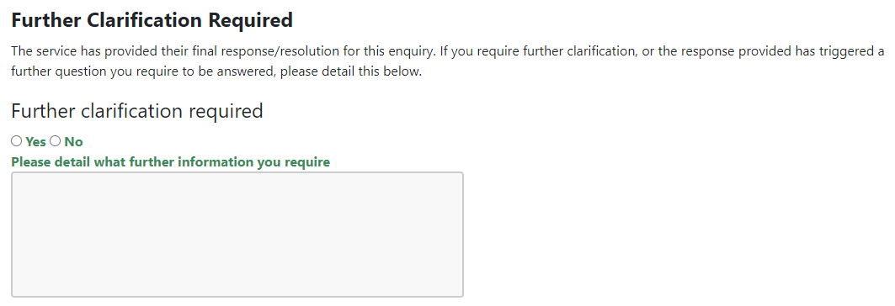
This will then put that enquiry back into the workflow of the relevant Service and the Caseload Controller will ensure it is actioned. The follow up response will come back to the member with the status again of Follow-up Response Provided. If they are then happy with the clarified/augmented response, the member should change the status to Member Request Resolved to close it.
Request Escalation: There are three primary routes whereby a member’s request can be escalated and these are detailed below.
    - Escalated due to unreasonable time taken by Service to respond to the enquiry
After an initial response has been provided by the Service, the status of an enquiry will normally change to Follow-up Response Pending (where further information is to be provided to the member) or Work Scheduled (where the member enquiry is an actionable request for the Service to do something e.g. review a council tax reduction decision). At this point in the process, the Service will provide a resolution due date of when the service can realistically provide the information or do the work:
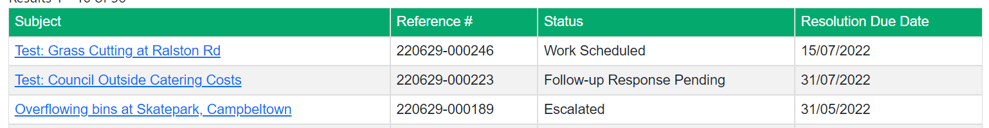
The resolution due date is shown in the table of enquiries on the Member Zone home page as detailed above. Whenever a Follow up Response has not been provided within 4 weeks of the target resolution due date, the incident will automatically be escalated. In the example above, incident ref 220629-000189 has a status of Escalated as it is 4 weeks beyond its target resolution due date of 31/05/2022.
When viewing details of this enquiry, a new section will be displayed at the top of the screen:
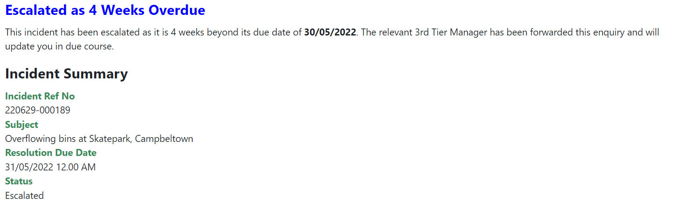
    - Escalated by Member as final response provided by Service is deemed insufficient
When a Service provides its final response to a member’s enquiry, the enquiry will be given a status of Follow-up Response Provided. At this stage in the process, it is important that the member reviews the Response given by the service, and provided they are content with the final response/outcome close the incident by changing the status to Member Request Resolved.
Note: there are currently 123 member requests sitting at that status on Member Zone; awaiting a decision by the member to close them or to follow the new processes outlined in this briefing.
If, however, a member is unhappy with the final response/outcome and they have used the additional information/clarification process outlined above, there is now the option to escalate the enquiry using the process detailed below:
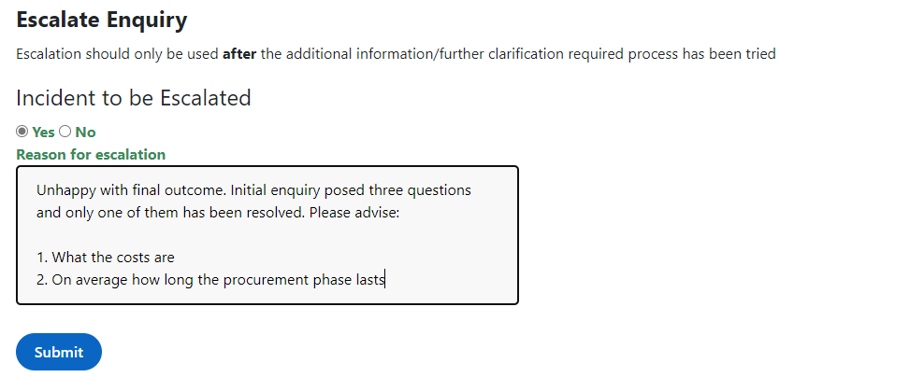
The member must select Yes below ‘Incident to be Escalated’ and detail clearly why they want the enquiry to be escalated in the ‘Reason for Escalation’ field. Once this has been done, click the Submit button and the enquiry will now have a status of Escalated.
Now when reviewing the incident in Member Zone, extra text will appear at the top of the screen:
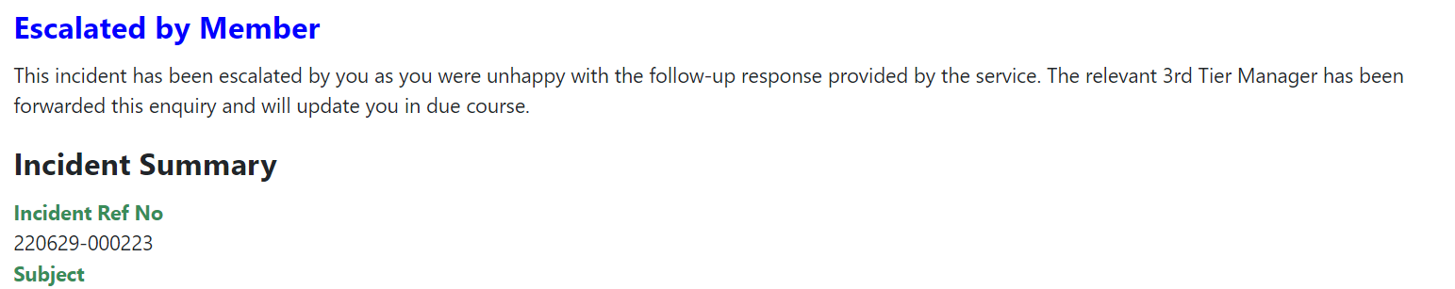
    - Escalated by Service as unable to do (or inform) anything further.
On very rare occasions, there can be differing opinions between a member and a Service as to whether or not an enquiry has been suitably responded to by the Service. If there is a deadlock between a member’s expectations and the ability for the Service as they see it to fulfil them, then the Service can also escalate an enquiry to a higher manager. If this happens, the incident will be given a status of Escalated and the following information will be displayed in Member Zone when viewing the incident:
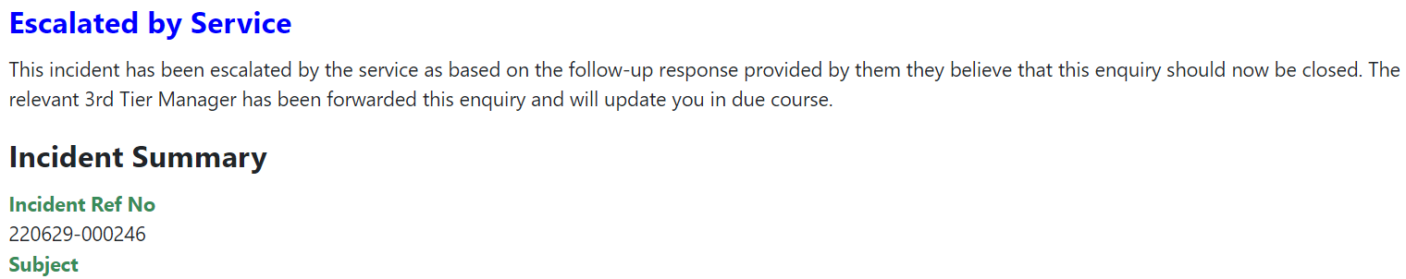
  - What happens when an enquiry is escalated?
Regardless of the reason for an enquiry being escalated (time-based, by member or by Service), when an enquiry is escalated an email will be sent to the relevant MZ Service Controller that is managing that enquiry. It is then their responsibility to pass the enquiry to the relevant Third Tier Manager for consideration and action.
The Third Tier Manager will take ownership of the enquiry and work with relevant officers and the member to get the enquiry resolved promptly. Once the enquiry has been resolved, the final outcome/resolution will be supplied by the Third Tier Manager to the relevant service controller and the update will be recorded in Member Zone and emailed to the Member. The enquiry status will return to Follow-up Response Provided. Hopefully the member will then be able to mark it Member Request Resolved.
- New form for Logging Non-Council Enquiries
An elected member brought to the development team’s attention the fact that they would like to use the MZ to control all of their constituent enquiries in one place, whether or not they were council related. So functionality has been added to allow this. At the bottom of the Enquiry Type page (reached by clicking on Log New Enquiry button on Homepage), a new option has been added for logging a non-Council enquiry:

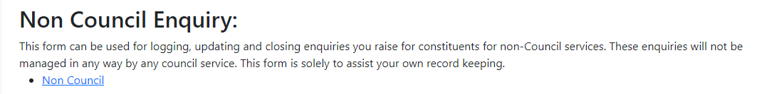

Clicking on Non Council will take Member to the following form:

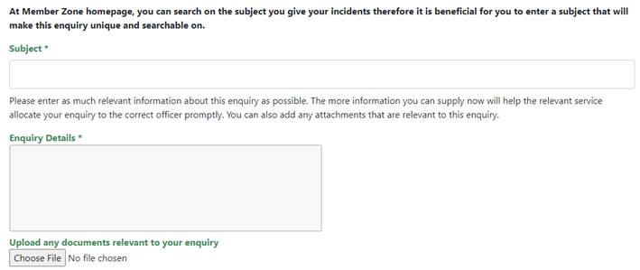
This form is for Members to log, manage and close enquiries that are not for Council services. There will be no input from Member Services or any other services across the Council for these enquiries; this form is solely for Members to manage enquiries from constituents for non-Council services. Any enquiries logged will show in the list of open member’s enquiries.
- Link to Organisation Chart Added to Enquiry Type Page
The following is another suggestion made by a newly elected member. When logging a service specific enquiry, the appropriate Service to choose it is not always clear (especially for newly elected Members). To help with this a link to the Council Organisation diagram has been added on the Enquiry Type page:

Clicking on this link will display the current Council Organisation chart:
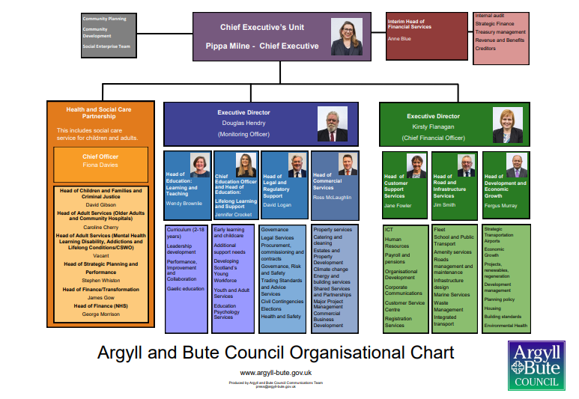
- Member Zone – Member Sounding Board
As noted at the Members’ induction in May, it is important that the members have ongoing input to the ongoing development and operation of the Member Zone. There is already a Feedback Form on the MZ that has been used by a number of members and as shown above the Development Team are happy to implement these improvements where possible. In addition to this we would like members to join the MZ Sounding Board, which will meet at least quarterly. The draft Terms of Reference are noted below and will be discussed at the upcoming Members’ Seminar.
To assist the effective running and continual improvement of the Member Zone by providing a forum that allows discussion of issues and enhancements relating to it:

- To identify and consider issues with the smooth running of the MZ request management system and service and propose and prioritise solutions for them.

- To make recommendations as to additional information resources that can be added to MZ that will assist members in the fulfilment of their role.

- To regularly review the Development Plan of enhancements for MZ and assist in the determination of development priorities.

- To review the performance of the MZ system and service by all stakeholders, considering the barriers to effective operation and propose measures to address these.

- To act as “critical friends” to MZ, for example in the testing of new enhancements before launch so that they best meet the needs of members.

- To promote the optimal use of MZ and provide input to communication and training products relating to it.

Some members have already indicated a willingness to be on the Board but if you would also like to attend, please let Helen MacLeod at Member Services know. Member Zone is just at the start of its evolution and we are keen that it continually improves to meet the needs of members.
----------------------------------------------------

If you require any further information or need any clarifications on the content of this Briefing, please do not hesitate to contact Member Services (memberservicesteam@argyll-bute.gov.uk, 01546 60 4305) or Jamie Robertson (01586 55 5202, jamie.robertson@argyll-bute.gov.uk).

Bob Miller Helen MacLeod
Customer Engagement Manager Member Services Officer
August 2022 August 2022

