Council Assets Including Buildings and Adopted Roads
Members are often interested to know what assets the council owns; particularly buildings and adopted roads as this information is useful to know when dealing with enquiries from constituents and Community Councils.
- Council Owned Property and Buildings:
The most comprehensive online resource for council assets is the Land and Asset Toolkit (argyll-bute.gov.uk) and this includes guidance on community asset transfers and the Register of Land and Assets.
The easiest way to find council assets is to use the Land and Property Assets Search on the council website: https://argyll-bute.maps.arcgis.com/apps/webappviewer/index.html?id=4426b461ba6d4e4c8d69937b07218096
This shows a map of the council area and every dot is an asset that can then be zoomed into and clicked on to find more information:
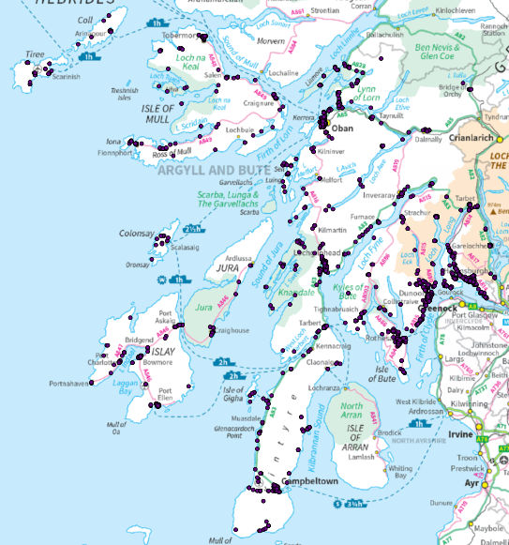
For example zooming in on Jura shows a number of assets and clicking on a dot gives this information
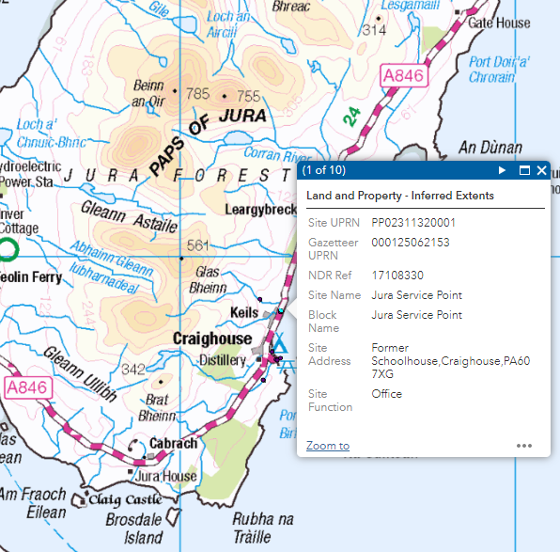
The council’s Property Team can be contacted with any specific enquiries about a property relate asset property@argyll-bute.gov.uk
- Adopted Roads Assets
A full .pdf document on the council website holds a list of all council adopted roads:
Public list of roads - Argyll and Bute Council area - March 2021 (argyll-bute.gov.uk)
This can be downloaded and it can also be searched using the road name, number or location in the search box in the top left corner . In addition there is also a searchable map layer on the council website map service:
Portal App (argyll-bute.gov.uk)
This can also be zoomed in on and the relevant information obtained, but first select the Adopted Roads option from the list that is provided when you open up the map layer (see highlights below):
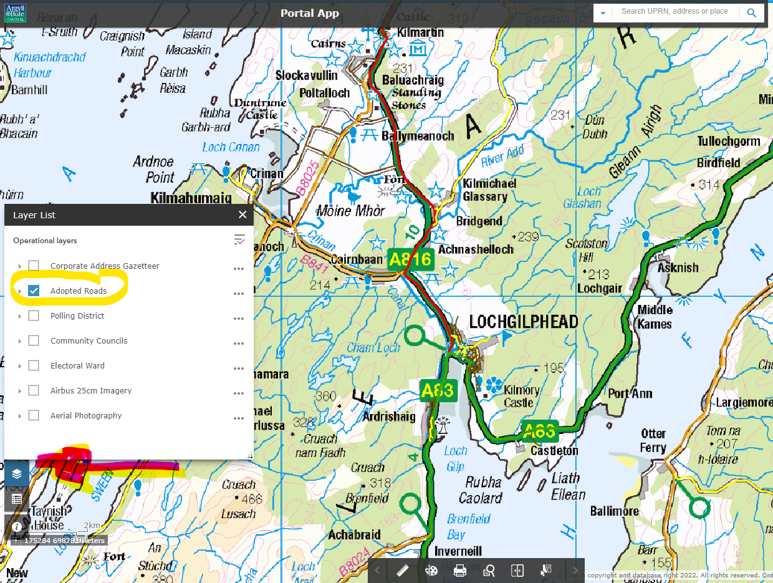
Another very useful resource for Members is information on the Roads Capital Programme of planned major repair and resurfacing works. This is broken down by area and can be seen here: Roads Capital Programme (argyll-bute.gov.uk) An excerpt is shown below:
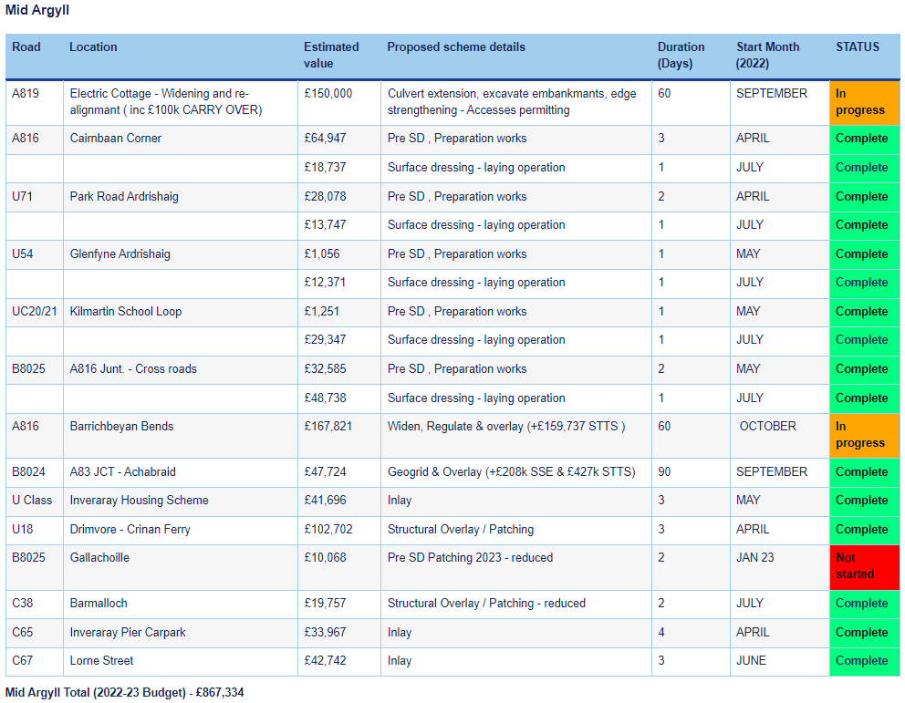
All enquiries regarding roads and lighting should be logged via the Member Zone request system.

