What is surface dressing and why do we do it?
Surface dressing is a cost effective road treatment which restores the road surface and seals it in one process.
There are a number of designs/types of surface dressing which range from a single dressing which has one layer of binder and one layer of chips to the more durable double dressing which incorporates two layers of chipping’s (the larger size on the bottom) and two applications of binder, the second one being placed between the new layers of chips. The bitumen (the glue which holds the stone chips in place) varies from simple emulsion binders to technically sophisticated polymer modified binders.
Surface dressing targets areas of road in the earlier stages of deterioration – it improves skid resistance, helps seal cracks and prevents water ingress (which is the main cause of deterioration) which protect previous investment and to extend the life of the existing roads.
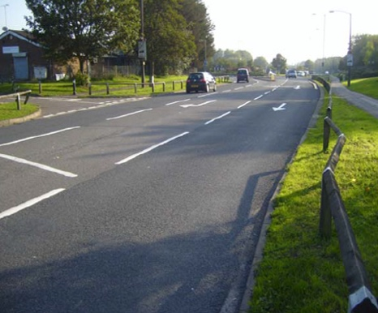
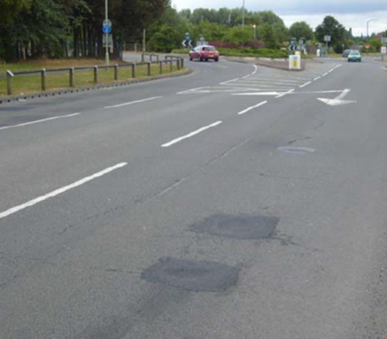
The same road approximately 3 months after the dressing was completed
The potholes on this road have been patched ready for dressing however the cracks in the old road surface are still visible. The dressing will fill and seal these.

Potholes are formed by water, freezing and freeze-thaw cycles, excessive heat, wear and tear – and time.
Roads are an integral part of our daily lives

- 500 thousand children (one half) of our nation’s school population are carried on 2,000 school buses 180 days per year.
- 1,000 ambulances make 20 million trips a year.
- Lorries carry 15 million tons of goods across the roads every day,
- 3.5 million registered vehicles travel 1 million miles annually.
When does surface dressing take place?
The surface dressing season is from May to September in Scotland but generally surface dressing
in Argyll will start in June and be completed by early August.
Work is carried out in the warmer months help to ensure that the binder sets and also to enable the stone chips to become embedded in the surface below – this works best when the road surface is warmer and softer.

Who carries out our surface dressing work?
The Council’s annual roads reconstruction programme uses a mixed-economy delivery model where some work is carried out by in-house teams and other work by external contractors.
For a number of years surface dressing has been carried out by an external contractor, which has proven to be the most effective way of delivering this particular type of treatment as the Council do
not have the specialised plant to complete this type of work.

How much do we spend on surface dressing?
The average spend is on average £1.5 million per year however the spend varies depending on the capital budget available and the schemes selected.
The table below illustrates the far greater network coverage achieved by surface dressing versus
other surface treatments.

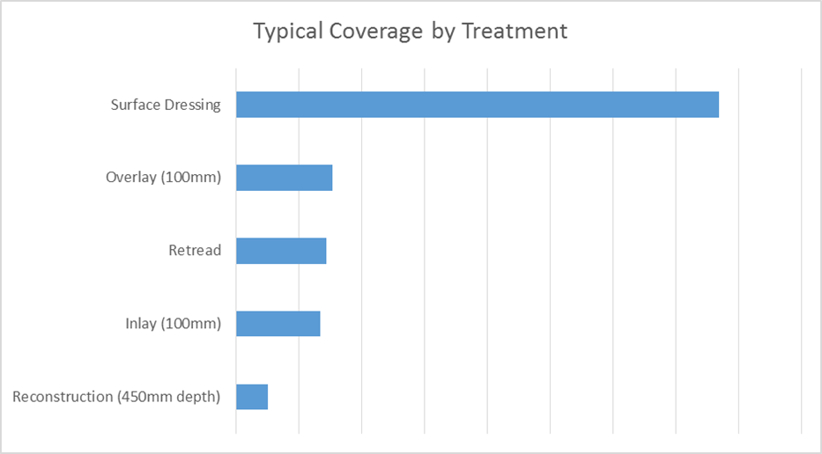

How do we choose which road requires surface dressing?
Schemes are recommended using the nationally agreed Road Condition Index which is a common system used by every Council in Scotland, combined with local knowledge and engineering principles and judgement. Some roads that are in relatively good condition will be treated with preventative maintenance treatments like surface dressing.
Other roads requiring more extensive treatments will be recommended for resurfacing when funding
is available.
The roads reconstruction programme is developed annually after the Council budget meeting in February, and the proposed programme is then recommended to Elected Members to agree.
This year’s programme was agreed by the Environment, Development and Infrastructure Committee on 3 March 2022 and is available here at item 6.

Why are loose chips not immediately cleared?
A surplus of chippings are required as part of the process to provide an even spread of aggregate
over the finished layer. It is normal to have loose chips on the road surface after surface dressing.
It can take several weeks for all the chips to fully embed into the road surface.
Mechanical sweeping will be in operation for up to 30 days with each site being swept normally
a minimum of three times.

Would a road be closed for surface dressing?
In general roads will not need to be closed for the surface dressing process.
Traffic management will be in operation at all sites and will normally be either stop/go boards
or convoy working.
Anyone carrying out works on the public road is required under the terms of the New Roads
and Streetworks Act 1991 to properly notify their works. In Scotland there is a national register
for roadworks which is available here
Can my vehicle be damaged by the loose chippings?
Warning signs are erected along with 20mph advisory speed limit signs. If all drivers adhere to the speed limit there should be no damage to vehicles.
If a member of the public wishes to make a claim or complaint, they should contact our contractor directly.

This year’s surface dressing contract is being delivered by Kiely Brothers and their dedicated email address is argyll-bute@kielybros.co.uk

Full details of all surface dressing schemes as well as the wider roads reconstruction programme
is available on the Council website here.
Please note that this is a snapshot of the programme at the current time and the dates may change depending on the weather.

