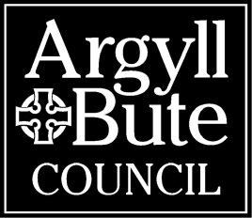
PIERS & HARBOURS
DANGEROUS GOODS PRE-ARRIVAL NOTICE

(As required by SOLAS 74, chapter VII, regulations 4.2 and 7-2.2, MARPOL, Annex III, regulation 4.2 and chapter 5.4, paragraph 5.4.3.1 of the IMDG Code)

1.1 Name of vessel & call sign |  |  |  |  | 1.2 Vessel particulars |  |  |  |  |  | 1.3 I.M.O. number
1.4 Vessel contact information |  |  | 2. Port of loading |  |  |  |  | 3. Port of discharge |  |  |  | 4. Estimated Time of Arrival
5.  U.N. Number | 6.  IMDG Reference Number | 7.  Proper Shipping Name |  | 8.  Stowage Position  On Deck  or  Under Deck |  | 9.  Proper Shipping Name/(Technical Specifications) | 10.  Class/ (Subsidiary Risk(s)) |  | 11.  Packing Group | 12.  Additional Information  Marine Pollutant /Flash point/etc. |  |  | 13.  Number and kind of packages | 14.  Mass (kg) or Volume (L) | 15.  EmS
16. Confirm permission of destination port for vessel’s arrival
16.1 Place and date
Signature of Master
Dangerous Goods in Harbour Areas Regulations 2016
Argyll and Bute Council do not possess Explosive Licences. Consequently no explosive substances are handled at any Argyll & Bute Council Harbour

