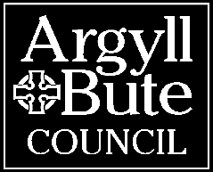 | APPLICATION FOR ROADS AUTHORITY CONSENT FOR THE PLACEMENT OF AN A-BOARD OR SIMILAR OBJECT
Roads (Scotland) Act 1984

For non-Council roads (e.g. Trunk Roads) application for consent should be made to Transport Scotland via development_management@transport.gov.scot

- Applicants Details (proprietor or responsible person)
Title
Forename
Surname
Company Name
Building Name/No.
Address 1
Address 2
Town/City
Postcode
Telephone
Mobile
Email

- Address / location descriptor of sign (postcode must be included)
A location plan must also be provided at either 1:50 or 1:100 scale and must clearly identify the proposed sign location. The plan must also identify the site by reference two named roads/streets.

- Sign Details
Please provide details of the sign:
Height (m)
Width (m)
Sign type (e.g. A-Board, “barrel”)
NB: consent will only be granted for signs located along the frontage of the property for which the advertisement is intended for.

- Indemnity of the Council
Public liability insurance, indemnifying the Council from all incidents arising from the sign, must be provide to a value of £5 Million. A copy of this insurance document must be submitted with this application.

Guidance

- When preparing you application consider the following points:
- Is the size of the sign proportionate to the advert?
- The type of materials the sign is made from.
- This type of sign will be freestanding (unfixed), you must ensure the sign is stable and not likely to pose a risk to other road users.
- Location – is there a better place to site the sign within the available frontage.
- Is the sign needed or is there a better way to advertise the business, for example, could a group of Businesses group together and use ‘column-style’ signage for sign-posting and promotion?
- When considering the location of the proposed sign you must ensure that the sign will not:
- Obstruct the sightlines of any bend, corner or road junction;
- Interfere with the visibility of any traffic sign or signal;
- Act as a distraction to drivers (text too small, too much information etc.);
- Simulate prescribed Road signs in content or colour;
- Obstruct or cause a danger to any road or footway user;
- Cause any other hazard to public safety;
- A-board requirements
- Be positioned at the rear of the footway (abutting the shop frontage);
- Businesses without a frontage are not eligible for an A Board;
- Only one A-board will be permitted per shop premises to prevent sign clutter;
- Minimum footway width of 1.8 metres required between board and carriageway;
- Must be located directly outside the premises the board relates to;
- Present no hazard to pedestrians or wheelchair users (e.g. sharp edges, protruding nails or moving or rotating signs which could injure children);
- Be no more than 0.6 metres wide;
- Be no more than 1 metre in height;
- Be sufficiently stable so as not to be easily moved or blown over;
- Be covered by Public Liability Insurance;
- A-boards must be removed from pavement areas when the shop premises are closed.

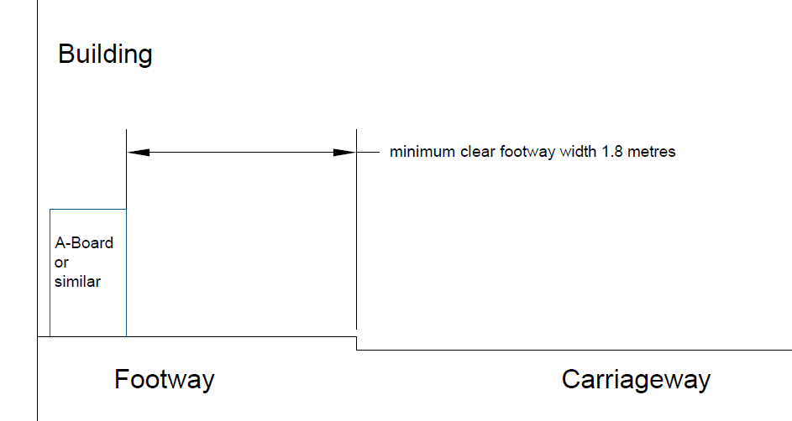

Applications should be returned to the relevant roads area team, see details below.

Oban and Lorn:
Jackson Quarry, Millpark Road Depot, Oban, PA34 4NH
RAenquiriesOLI@argyll-bute.gov.uk

Mid Argyll, Kintyre and Islay:
Manse Brae, Lochgilphead, PA31 8RD
RAenquiriesMAKI@argyll-bute.gov.uk

Helensburgh and Lomond:
The Helensburgh and Lomond Civic Centre, 38 East Clyde Street G84 7PG
RAenquiriesHL2@argyll-bute.gov.uk

Bute and Cowal:
Milton House, Dunoon PA23 7DX
RAenquiriesBC@argyll-bute.gov.uk
Roads Customer Services: 01546 605514

