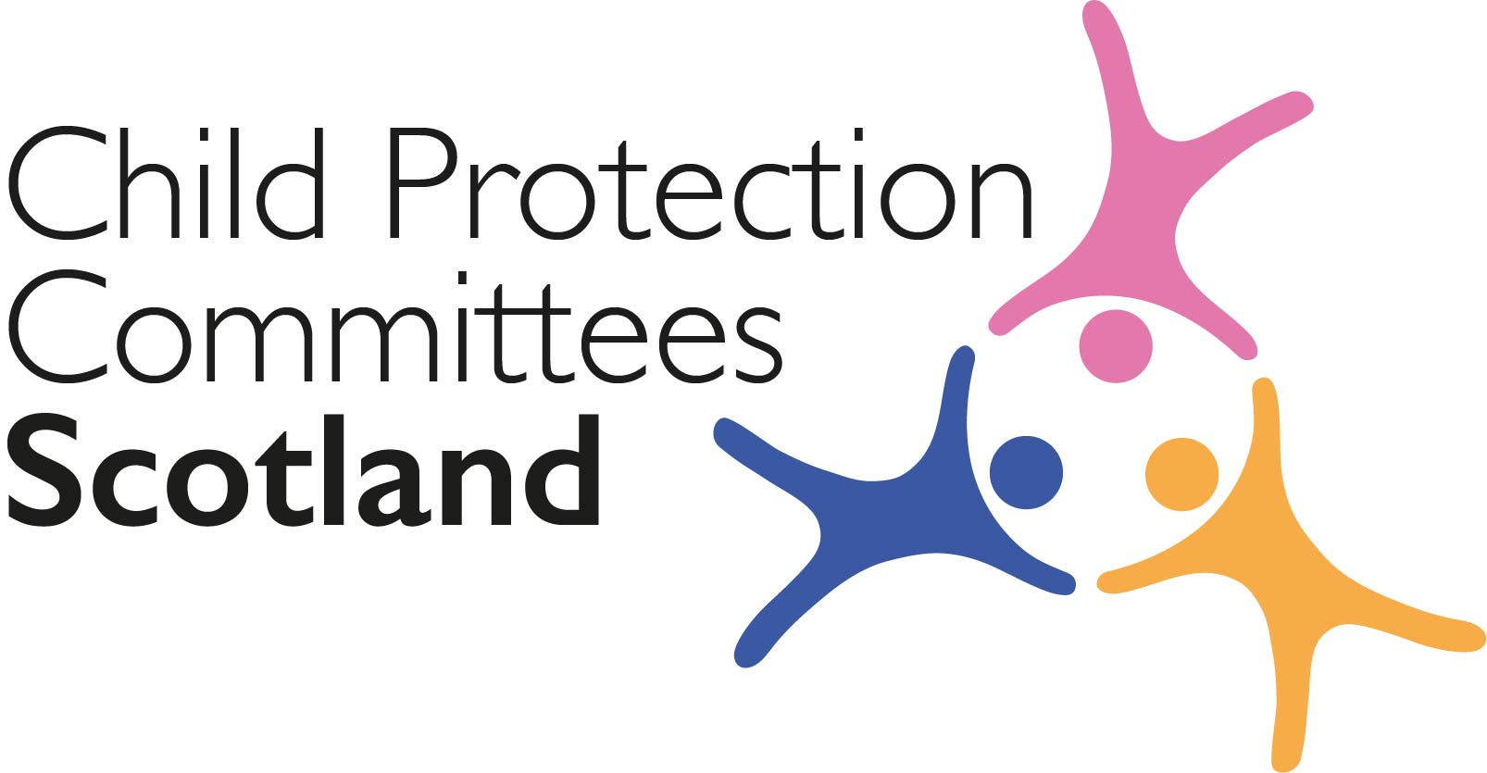
Keeping Connected - The CPCScotland Weekly Bulletin

Issue 57 - Tuesday 18th May 2021

Issued to support Child Protection Committees and partners with up to date information on child protection issues.

Welcome to Issue 57 of Keeping Connected.

This week’s bulletin is particularly well stocked with research and evidence based reports. Thanks to Colin Anderson, Karen Frew and others in the team at Glasgow for providing many of the links.

As always please let us know of any local work your CPC is involved with so that we can highlight it in the bulletin. If your area has published new guidance, research/evaluation findings or resources related to child protection or who is embarking on a new way of working that you can share with others we would love to hear from you. Contact Susan Mitchell at
cpcscotland-liaison@strath.ac.uk

You will also see that the Child Safeguarding Practice Review Panel has been busy publishing a number of reports including findings from the analysis of completed local child safeguarding practice reviews and rapid reviews. It will be interesting to compare the themes from this report with those in or own triennial review when it is published in June.

Keep safe and keep in touch.

Alan Small, Chair Child Protection Committees Scotland

ANNOUNCEMENTS

1 Publications from the Child Safeguarding Practice Review Panel

The Child Safeguarding Practice Review Panel in England has published its independent annual report for serious child safeguarding incidents in 2020. This is the Panel’s second annual report, covering their work from 1 January 2020 to 31 December 2020. It sets out the panels views about how effectively the system of reviews across England, including Local Child Safeguarding Practice Reviews (LCSPRs) is operating.
https://www.gov.uk/government/publications/child-safeguarding-practice-review-panel-annual-report-2020

The Panel has also published findings from analysis of 33 completed local child safeguarding practice reviews (LCSPRs) in England received in the period 1 October 2019 - 31 December 2020 and a sample of 135 rapid reviews completed in the period January – December 2020. This review was undertaken by the University of East Anglia and the University of Birmingham. Key themes identified include: opportunities to be curious; inter-agency communication and sharing; policies and protocols; and training. New themes that would benefit from further exploration include: working with families during a pandemic; peer-on-peer abuse; young people’s gender and sexual identities; and trafficking of children.
https://assets.publishing.service.gov.uk/government/uploads/system/uploads/attachment_data/file/984770/Annual_review_of_LCSPRs_and_rapid_reviews.pdf

2 CELCIS Recruitment Protecting Children Consultant - Reminder

CELCIS are currently recruiting for a Protecting Children Consultant. Closing date 21st May.
https://www.celcis.org/about-us/work-us/protecting-children-consultant/

3 Missing People Training and Consultancy - Reminder

The deadline to apply to be part of the next phase of the free programme of consultancy, training and best practice sharing in selected local areas in Scotland, offered by the 3rd sector organisation Missing People is 21st May 2021. See the letter previously circulated to CPC Chairs and Lead Officers or contact Annie Marshall at annie.marshall@missingpeople.org.uk for more information.

Guidance, Resources and Information

4 Analysis of Safeguarding Partners’ Yearly Reports 2019-20

What Works for Children’s Social Care and the Child Safeguarding Practice Review Panel have published have published a report setting out key findings from a compliance audit and ‘deep dive’ analysis of safeguarding partnerships’ yearly reports. Findings from analysis suggests that yearly reports could benefit from a sharper focus on impact, evidence, assurance and learning. https://whatworks-csc.org.uk/wp-content/uploads/Analysis_of_Safeguarding_Partners_yearly_reports_2019-20_Overview_report_May2021.pdf
5 Wood Review of multi-agency safeguarding arrangements
The Department for Education (DfE) has published a review setting out recommendations for making new multi-agency safeguarding arrangements for local areas in England more effective.
https://www.gov.uk/government/publications/wood-review-of-multi-agency-safeguarding-arrangements

6 Parents with alcohol and drug problems

Public Health England (PHE) has published a toolkit containing guidance, data and other resources to support professionals who are helping families affected by parental alcohol and drug problems. The resources include: planning and operational guidance for adult alcohol and drug treatment services and children’s services showing how services can work together to support families affected by parental alcohol and drug problems; and a guide to using case studies to estimate how much money can be saved by supporting families who experience problem parental alcohol and drug use.
https://www.gov.uk/government/publications/parents-with-alcohol-and-drug-problems-support-resources

7 Foxgrove - The National Secure Adolescent Inpatient Service

The new National Secure Adolescent Inpatient Service for Scotland (NSAIS) aims to meet the needs of young people in Scotland who require secure inpatient care. The unit will be on the Ayrshire Central Hospital campus in Irvine, North Ayrshire and has officially been named ‘Foxgrove’. More information and a Virtual Walkthrough of the proposed design for the site is available at the link below.

https://www.nhsaaa.net/hospitals/foxgrove/

8 COVID-19 Guidance and Training Resources

Scottish Government has produced guidance for early learning and childcare settings, childminding services and school age childcare settings. There are also 2 animations that staff can use for training purposes and to speak about behaviours that support the public health guidance.
- Early Learning and Childcare
- Childminding
- School Age Childcare

9 CyberScotland Bulletin

The May 2021 CyberScotland bulletin is now available online.
https://www.cyberscotland.com/may-2021/

This month the bulletin contains information and links to a new security training package for schools and charities published by The National Cyber Security Centre available as a scripted presentation and a self-learn video.
https://www.ncsc.gov.uk/information/cyber-security-training-schools
https://www.ncsc.gov.uk/blog-post/training-for-small-organisations-and-charities-now-available

Training, Learning Events and Resources

10 Relationship-based practice in a digital world – 27 May

This free event in partnership with IRISS, Social Work Scotland and the Scottish Association of Social Work (SASW) will explore what we have learned over the past year about creating and maintaining relationships through the use of technology. It'll provide the Scottish policy context; evidence about how our national capacity is developing; and examples of innovation and development in digital social work. Delegates’ collective views and experiences will also be brought together to inform and support further work on what we now know is an important and evolving area of practice. The event takes place on 27 May and runs from 10 am – 12noon.
https://www.iriss.org.uk/news/events/2021/04/26/relationship-based-practice-digital-world

11 Child mental health

The Association for Child and Adolescent Mental Health (ACAMH) has released a podcast discussing reasons why mental health difficulties in vulnerable children increased during lockdown and looking at findings from a study of 148 primary school children aged 4–8 years who were identified as ‘at‐risk’ for mental health problems by teachers.
https://www.acamh.org/blog/increased-mental-health-difficulties-in-vulnerable-children-during-lockdown-dolapo-adegboye/

12 Exploitation 2021 - Tackling the Culture and Challenges of Trafficking, Slavery and County Lines
The Association of Child Protection Professionals are holding a two-day event on 24-25 June 2021 with expert keynotes and more than 20 workshops and presentations on all aspects of exploitation. Please note there is a fee to attend (members rate £79 for 2 days, non members rate £99 for 2 days, single day rates are also available).
https://www.childprotectionprofessionals.org.uk/Event/exploitation-2021

For Children, Families and Communities

13 COVID-19 Materials for schools and childcare settings

The Scottish Government has created new resources to encourage safe behaviours by families, and to help parents and carers to understand the steps that they can take to reduce the risk of Covid-19 transmission. These are
- A PDF that can be shared by email (or printed where appropriate) highlighting the 6 key things that families can do to keep communities safe
- A poster that can be printed by settings, reminding families that children shouldn’t attend ELC if anyone at home has symptoms or is waiting for test results.
- Social media resources including pictures and suggested text
- Suggested text and whatsapp copy detailing the important steps everyone should follow.
These can all be accessed via WeTransfer. If you can’t use WeTransfer other download links are available from cpcscotland-liaison@strath.ac.uk
https://union.wetransfer.com/downloads/5098254b598ba8ce2a62b75b5efe37ee20210514093305/8a8d2a

14 Helping to improve the way children’s hearings work for young people

The Voice and Inclusion Project (VIP) has been set up by CELCIS for children and young people with care experience to come together to work with us so that we can find and create ways to improve the experiences of children and young people when they take part in a hearing. We are keen for young people to be involved at every stage, from determining the questions to ask, to developing methods of how we might find out the answers to the questions, collecting information, and the ways in which we will tell people what we have found out at the end. Involvement can be from a week or two, or the duration of the project, up to two years. There are some paid opportunities, as well as the chance to shadow researchers. CELCIS will host online information events for anyone interested in taking part.
https://www.celcis.org/files/6816/2081/9000/VIP_-_Voice_and_Inclusion_Project_flyer.pdf

Research and Evidence Based Reports

15 COVID-19 and Violence Against Children

A review of the literature that has been produced on children’s exposure to violence during the pandemic.
https://www.sciencedirect.com/science/article/pii/S0145213421001265?via%3Dihub

16 A Year Like No Other

A report from Centrepoint, which reflects on the impact of the COVID-19 pandemic on vulnerable young people; covering youth unemployment, homelessness, poverty and mental health.
https://centrepoint.org.uk/media/4774/a-year-like-no-other-executive-summary.pdf

17 Examination of the links between parental conflict and substance misuse and the impacts on children’s outcomes

This Department for Work and Pension’s report is a literature review examining the links between parental conflict and substance misuse and the impacts on children’s outcomes.
Links between parental conflict and substance misuse and the impacts on children’s outcomes

18 Building a food system that works for everyone

The Institute for Public Policy Research (IPPR) has published a report on the vulnerabilities of the UK food system with a series of recommendations for the UK and devolved governments, as well as local authorities, to start addressing these challenges.

https://www.ippr.org/research/publications/building-a-food-system-that-works-for-everyone

19 'How do young people learn about sex?' Research report

Zero Tolerance undertook this study to gain an understanding of how young people learnt about sex as teenagers and how this consequently informed their attitudes as adults. The 22-question survey was aimed at 18–25-year-olds generated 118 analysable responses.
https://www.zerotolerance.org.uk/news/news-events/how-do-young-people-learn-about-sex-research-report/

20 Persistence and Course of Mental Health Problems from Childhood into Adolescence

An analysis of the prevalence, course, and persistence of mental health problems over 10 years from childhood into adolescence, based on a sample from the Future Family project in Germany.
https://bmcpsychology.biomedcentral.com/articles/10.1186/s40359-021-00535-4

21 The Mediating Role of Attachment and Mentalising in the Relationship Between Childhood Trauma, Self-Harm and Suicidality

A study which aimed investigate the role of attachment and mentalising as potential mechanisms in the relationship between childhood trauma, self-harm and suicidality.
https://psyarxiv.com/d6j89/

22 Fathers’ experiences of lockdown
The Fatherhood Institute has published a report looking at fathers’ experiences of lockdown, when many were spending more time with their children. Findings from a survey of 2,045 fathers of children under the age of 12 in June 2020 following the first UK lockdown, diary records (kept by 30 fathers) and follow-on interviews with 15 fathers include: fathers spent more time and built stronger relationships with their children; got better at parenting and grew in confidence; and gained greater insights into their partners’ caring roles.
http://www.fatherhoodinstitute.org/2021/what-was-lockdown-like-for-dads-and-how-can-we-keep-the-best-bits/
News and Opinion

23 In the media

- Holyrood magazine has published an article on Kirsty the fictional Holyrood baby and the impact the COVID-19 public health emergency has had on her family
https://www.holyrood.com/inside-politics/view,the-holyrood-baby-at-five-a-childhood-scarred-by-poverty

- The Guardian has reported on a study led by Glasgow University, funded by the Scottish Government and published in the Lancet Psychiatry, which found that four in five female prisoners in Scotland were found to have a history of head injury, with a first head injury before the age of 15 reported by 69% of the women – almost all participants in the study, 95%, also reported a history of abuse, with more than half reporting sexual abuse in childhood: https://www.theguardian.com/society/2021/may/13/four-in-five-female-prisoners-in-scotland-found-to-have-history-of-head-injury

- Child Safeguarding Practice Review Panel has said that the UK Government must “strive to keep schools open” in the event of future lockdowns. This follows the publication of data which revealed that cases of child abuse and death in England increased by 27% during the first wave of COVID-19. https://www.sundaypost.com/politics/keep-schools-open-over-future-lockdowns-to-protect-children-experts-say/

- The Sunday Times Scotland has reported on MSP Christine Grahame’s call for an independent inquiry into Scottish Borders Council’s handling of child abuse claims against a teacher at a school for children with special needs: https://www.thetimes.co.uk/article/call-for-inquiry-into-botched-school-abuse-case-pbvzjnv5j

- Nazir Afzal, the former prosecutor, who oversaw 19 convictions during the prosecution of those involved in the Rochdale grooming scandal, will be appointed as chairman of the new Catholic Safeguarding Standards Agency, which has been created in response to severe criticism of child safety lapses in the Church by the Independent Inquiry into Child Sex Abuse (IICSA):
https://www.thisismoney.co.uk/news/article-9583117/Ex-prosecutor-Nazir-Afzal-head-Catholic-Churchs-drive-stamp-child-abuse-scandals.html

- Community Care reports that the Association of Directors of Children’s Services (ADCS) has given partial backing to the government’s proposed reforms to the asylum system for unaccompanied children. The news story cites the ACDS's response to the government’s consultation in which they support plans to introduce a National Age Assessment Board (NAAB), which would set out the criteria, process and requirements for age assessments.
https://www.communitycare.co.uk/2021/05/10/directors-give-partial-backing-proposed-asylum-reforms-unaccompanied-children/
24 Young people speak to Childline about mental health and abuse during the pandemic
The NSPCC has released figures which show that, since April 2020: the Childline service has carried out 73,088 counselling sessions with children and young people about mental or emotional health, 5,646 of which were sessions with children aged 11 or under, an increase of 29% when compared to the previous year. Figures also show that in 2020/21, the first full year of living under Coronavirus restrictions, Childline has delivered 16,610 counselling sessions about abuse - with counselling sessions about emotional abuse showing an increase of 18% when compared to the year before.
https://www.nspcc.org.uk/about-us/news-opinion/2021/children-counselling-sessions-covid-pandemic/

25 Blueprint for better maternity care in Scotland

The Royal College of Midwives (RCM) have published a Blueprint for maternity services, identifying five areas for action including tackling social deprivation.
https://www.rcm.org.uk/media/4903/blueprint-for-better-maternity-care-in-scotland-april-2021.pdf

26 Online Safety Bill

The UK Government has published a Draft Online Safety Bill which is intended to protect young people and clamp down on racist abuse online, while safeguarding freedom of expression. The NSPCC has however issued a statement in response highlighting their ‘significant concerns that the Draft Online Safety Bill risks falling to respond and tackle the child abuse threat.’ It said ‘UK Government is failing to learn the lessons of effective regulation in other sectors.’

https://www.gov.uk/government/news/landmark-laws-to-keep-children-safe-stop-racial-hate-and-protect-democracy-online-published

Please let us know what you think about the bulletin and provide information for inclusion in future editions. Contact Alan Small or Susan Mitchell at cpcscotland-liaison@strath.ac.uk.

Please note that the information included in this bulletin is provided in good faith. Inclusion does not indicate CPCScotland endorsement of the content of the linked documents or websites.

