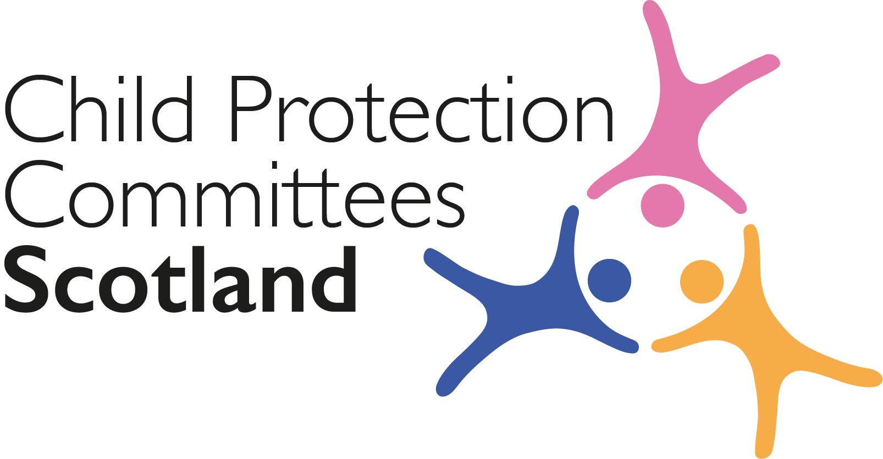
Keeping Connected - The CPCScotland Weekly Bulletin

Issue 55 - Tuesday 4th May 2021

Issued to support Child Protection Committees and partners with up to date information on child protection issues.

Welcome to Issue 55 of Keeping Connected.

As we approach the Scottish Parliament Elections on Thursday of this week we will all be hoping that whatever the outcome the wellbeing and protection of children will be a key priority for those in positions of political power. This week’s issue of Keeping Connected has plenty to keep you occupied as we await the results.

Keep safe and keep in touch.

Alan Small, Chair Child Protection Committees Scotland

ANNOUNCEMENTS

1 CELCIS Vacancies

CELCIS are currently recruiting the following five posts:
- Research Associate (closing date Friday 14 May)
- Protecting Children Consultant (closing date Friday 21 May)
- Permanence Consultant (closing date Friday 14 May)
- Improving Care Experiences Consultant (x2) (closing date 28th May)
https://www.celcis.org/about-us/work-us/

The direct link for the Protecting Children Consultant is below
https://www.celcis.org/about-us/work-us/protecting-children-consultant/

Please share with colleagues who may be interested.

2 Missing People Training and Consultancy

Missing people, in partnership with Scottish Government, deliver a free programme of consultancy, training and best practice sharing in selected local areas in Scotland in line with The National Missing Persons Framework. To date they have delivered the project in 6 Local Authority areas and from May 2021, they will be extending this offer of free support to five additional areas in Scotland. A letter with further information will be shared directly with CPC Chairs and Lead Officers this week. Interested areas are invited to submit an application form by Friday the 21st of May. More information is available from the National Coordinator for Scotland, Annie Marshall at annie.marshall@missingpeople.org.uk

Guidance, Resources and Information

3 Delivering Youth Work During Covid -19

YouthLink has published new guidance - ‘COVID-19: Guiding Framework to support the delivery of youth work services’. ‘https://www.youthlinkscotland.org/media/5974/youth-work-covid-19-guidance-framework.pdf

4 Child Winter Heating Assistance & ‘Best Start’ statistics

The Scottish Government has published statistics on the Child Winter Heating Assistance payments since they began in winter 2020 and high level statistics on the Best Start Grant and Best Start Foods since the payments were introduced in 2018 and 2019 respectively:
https://www.gov.scot/publications/child-winter-heating-assistance-payments-in-winter-2020-2021/
https://www.gov.scot/publications/best-start-grant-and-best-start-foods-high-level-statistics-to-28-february-2021/

5 Developing Participative Practice

CYCJ have published an info sheet which shares practical tips on how to further develop participative practice in your work. These tips have come directly from members of STARR, Youth Just Us and individuals who have shared their wisdom and insight in the development of CYCJ’s participation strategy.
http://www.cycj.org.uk/wp-content/uploads/2021/04/Info-Sheet-95.pdf

6 CHS Business and Corporate Parenting Plan 2021-22

Children’s Hearings Scotland have launched their 2021-22 Business and Corporate Parenting Plan.
https://www.chscotland.gov.uk/resources/reports-and-planning/chs-business-and-corporate-parenting-plan-2021-22/

7 National Adult Protection Co-ordinator Newsletter April 2021

The April 2021 edition of this newsletter is now available. The aim of this newsletter is to provide an outline of news and events that may be of interest to those in the adult protection field. To subscribe go to
https://khub.us18.list-manage.com/subscribe?u=cceb39733f2e9a839ef0e835f&id=603a96b0c2

8 Time For You

Time for You is an online and virtual mental health support service, providing help for frontline workers across Scotland during the pandemic. This ranges from people working in the health and social care sectors, to those providing the nation’s supply, logistics, retail and public transport. Time for You is provided by SAMH, in partnership with Glasgow Caledonian University and (LLTTF) Living Life to the Full.
https://www.samh.org.uk/about-us/our-work/time-for-you

Training, Learning Events and Resources

9 MARAC Deep Dive events

The National MARAC Advisory group is organising a series of deep dive discussions to explore how multi-agency risk assessment for victims of domestic abuse in Scotland can be improved. The full list of these events has now been published. Of particular interest to members may be the session on Children and Young People on Tuesday 22nd June.
Follow the links for more information and to book a place
- Whole System Response / Risk Assessment, Tuesday 25 May 2021
- Information Sharing, Tuesday 1 June 2021
- Collective Leadership and Accountability, Tuesday 8 June 2021
- Training, Tuesday 15 June 2021
- Children and Young People, Tuesday 22 June 2021
- National Guidance / Statutory Footing, Tuesday 29 June 2021
- Intersectionality and Authentic Voice, Tuesday 6 July 2021

10 Working in partnership with families through participative meetings
On 26 May at 11:00am, the University of Cardiff is hosting a free online event on international research evidence about shared-decision-making family meetings – involving family members in decision making where there are concerns about a child, rather than key decisions being made in a professionally-led case conference – including a presentation on how two English local authorities have recently expanded the use of such meetings.
https://cardiff.zoom.us/webinar/register/1916164340177/WN_wmsIfsFdQ8ek6EMF1WI9Gg

11 Harmful sexual behaviour in schools training
NSPCC Learning has relaunched their online training courses to help manage harmful sexual behaviour in primary or secondary schools in the UK. The courses are designed to provide the knowledge and skills to recognise, report and record sexualised behaviour concerns. Please note there is a cost of £35 per person to attend.
https://learning.nspcc.org.uk/training/harmful-sexual-behaviour-hsb-schools#

12 Children and Young People and Technology Assisted Harmful Sexual Behaviour: May 13
CYCJ are hosting a free webinar on 13th May during which Stuart Allardyce (Director, Stop it Now! Scotland) will look at key messages for practitioners from research around identification, assessment and interventions as well as sharing early findings from ROSA, Stop It Now! Scotland’s project working with children and young people who have displayed harmful sexual behaviours online. https://www.eventbrite.co.uk/e/technology-assisted-harmful-sexual-behaviour-and-children-and-young-people-tickets-145652738261

13 Exploring the Principles, Components and Applications of the Safe & Together Model – Webinar series

This is a four part free webinar series where David Mandel, Executive Director and Founder of the Safe & Together Institute, outlines key aspects of the Safe & Together Model and shares tools to help you become more domestic violence-informed in your systems and practice. Whether you have undertaken training in the Model or are new to the Model, these webinars are opportunities to learn, ask questions and receive concrete guidance on becoming more domestic violence-informed in your systems and practice.
Register Here

Research and Evidence Based Reports

14 Social Worker and Midwife Decision Making Regarding Child Protection Risk and the Unborn Baby

A paper which explores the perspectives and experiences of midwives and child protection social workers regarding the protection of unborn babies within Northern Ireland.
https://onlinelibrary.wiley.com/doi/10.1002/car.2661

15 Adverse Childhood Experiences and Trauma-Informed Care

New research has highlighted the need for increased trauma-informed care for children to help to mitigate the short- and long-term effects of Adverse Childhood Experiences (ACEs) on their development.
https://www.jpedhc.org/article/S0891-5245(20)30231-5/fulltext

16 Data Poverty in Scotland & Wales

Nesta commissioned demographically representative polling of over 2,000 people in Scotland and Wales in late January 2021 to explore data poverty - defined as ‘those individuals, households or communities who cannot afford sufficient, private and secure mobile or broadband data to meet their essential needs’.
Key findings include:
- One in seven adults in Scotland and Wales are experiencing data poverty
- Data poverty widens inequalities
- Connected but compromised, one in ten people with monthly mobile contracts regularly run out of data before the end of the month and larger households struggle to meet very high data needs.
- Financial and data literacy compounds data poverty
https://www.nesta.org.uk/report/data-poverty-scotland-and-wales/

17 A Narrative Review of Reviews of Interconnecting Risks of Mental Health Problems for Young People

A narrative review which examined the most prevalent multiple or interconnecting risks of mental health problems and examined those most prevalent for children and young people.
https://onlinelibrary.wiley.com/doi/10.1111/1467-6427.12344

18 Unsafe Children – Driving up our country’s response to child sexual abuse and exploitation

The Centre for Social Justice has published ‘Unsafe Children – Driving up our country’s response to child sexual abuse and exploitation’, a UK report which was written with input from a group of survivors of child sexual abuse.
https://www.centreforsocialjustice.org.uk/wp-content/uploads/2021/03/CSJJ8804-Unsafe-Children-210325-WEB.pdf

19 Children missing from care

Missing People has published a report on children and young people’s views on being reported missing from care. Findings from a series of consultations with 27 children and young people (24 female and 3 male) aged 13-18 who had been missing in the past include: carers, social workers and the police should avoid making assumptions about young people and why they might have gone missing; and young people do not want the police to automatically be contacted when they go missing and want decisions around contacting the police to be made based on their own unique situation.
https://www.missingpeople.org.uk/wp-content/uploads/2021/04/Childrens_views_on_being_reported_missing_from_care.pdf

20 Abused by the Patriarchy: Male Victims, Masculinity, Honour- Based Abuse and Forced Marriages

Research exploring the ways that men, particularly younger males and those who do not conform to cultural norms of masculinity become victims of honour-based violence and abuse.
https://journals.sagepub.com/doi/full/10.1177/0886260521997928

21 Delivering services virtually

NSPCC Learning has published an evaluation of delivering Pregnancy in Mind (PiM), a preventative programme for parents who are experiencing or at risk of mild to moderate anxiety and depression during the perinatal period, virtually during the coronavirus pandemic. The evaluation of case data identified some improvements in parental mental health and some advantages for programme delivery including: parents who experienced higher levels of depression and anxiety showed the greatest improvement over six sessions of the virtual delivery of PiM; and the flexibility of the programme provided opportunities for strengthening relationships with parents and providing tailored support.
https://learning.nspcc.org.uk/research-resources/2021/pregnancy-in-mind-virtual-service-evaluation

22 Children’s media use and attitudes (x2 Ofcom reports)
Ofcom has published a report looking at the media use and attitudes of children and young people aged 5-15. Findings show that in 2020: nearly all children aged 5-15 went online; just over half of 12-15s have had some form of negative online experience, the most common of which was being contacted by someone they did not know who wanted to be their friend which happened to almost a third of children; awareness of reporting functions was high (70% of children aged 12-15), but only 14% of 12-15s have ever reported content.
https://www.ofcom.org.uk/__data/assets/pdf_file/0025/217825/children-and-parents-media-use-and-attitudes-report-2020-21.pdf

Ofcom has also published the seventh wave of the Children’s Media Lives study. This longitudinal study of children’s digital media use started in 2014. Since then, they have tracked the online behaviours and experiences of 18 children aged between eight and 18. gaining insight into how different factors affect children’s media use, including age, family, social life and society as a whole. The latest report found that TikTok continued to be a dominant social media platform in 2020; and most of the children reported multi-screening (using multiple devices simultaneously).
https://www.ofcom.org.uk/__data/assets/pdf_file/0027/217827/childrens-media-lives-year-7.pdf

23 Safer Internet Day 2021

The UK Safer Internet Centre has published a report looking at the reach of Safer Internet Day 2021 and the impact it had on children, young people, parents, carers, and teachers. The report finds that 51% children aged 8-17 years across the UK heard about Safer Internet Day, of which: 82% said they felt more confident about what to do if they were worried about something online; 85% said they know what to do if they or someone else see misleading or unreliable content online; and 63% had a conversation with a parent or carer about online safety.
https://d1afx9quaogywf.cloudfront.net/sites/default/files/Safer%20Internet%20Day%202021/Safer%20Internet%20Day%202021%20Impact%20report.pdf

News and Opinion

24 In the media

- The ‘What Matters to You’ project, where families and young people determine their needs and the system offers that support in response, which stemmed from the Independent Care Review and is now part of The Promise, has received £2 million of funding from the Hunter Foundation and BBC Children in Need to develop its services in Tayside and East Ayrshire over the next three years: https://www.heraldscotland.com/news/19254719.entrepreneur-sir-tom-hunter-childrens-charity-team-2m-pledge-give-youngsters-better-life/

- The BBC has reported on data from 50,000 pupils and a survey of schools across England which shows that there is an increase in the number of four and five-year-olds needing help with their speech and language, which the Education Endowment Foundation (EEF) suggests could be because of measures taken to combat the pandemic depriving the youngest children of social contact and experiences essential for increasing vocabulary:
https://www.bbc.co.uk/news/education-56889035

- The UK Government’s Department for Education (DfE) has published a blog post by social worker Lee Pardy-McLaughlin OBE celebrating social workers’ passion, tenacity and commitment to helping children and young people:
https://socialworkers.blog.gov.uk/2021/04/27/social-workers-resilient-tenacious-and-committed-to-helping-children-and-young-people/

- The NSPCC has reported a record number of calls to their child abuse helpline in the last 12 months from people concerned about children’s welfare – of these calls, the number of referrals involving children made by the helpline to agencies in Scotland has risen by 40%: https://www.heraldscotland.com/news/19265749.deeply-worrying-child-abuse-referrals-soar-40-scotland-pandemic/

- A new web series has been launched to support children growing up online to navigate the internet safely – the series, a collaboration between a Robert Gordon University academic and East Renfrewshire’s Woodfarm High School and Eastwood High School, will focus on topics including online bullying, managing online information, copyright and ownership, privacy and security and online reputation
https://futurescot.com/web-series-launched-to-support-children-growing-up-online-to-navigate-the-internet-safely/

- The next Scottish Government must “significantly accelerate” progress in reforming employability support to help deliver Scotland’s legal child poverty targets, according to a new report from One Parent Families Scotland (OPFS), with funding and support from Oxfam Scotland.
Scotland’s child poverty targets “destined for failure” unless employability schemes are overhauled, charities warn

25 UK Domestic Abuse Bill receives Royal Assent
The UK Domestic Abuse Bill received Royal Assent on Wednesday, 28 April, recognising children as victims of abuse, not just witnesses.
https://bills.parliament.uk/bills/2709

Please let us know what you think about the bulletin and provide information for inclusion in future editions. Contact Alan Small or Susan Mitchell at cpcscotland-liaison@strath.ac.uk.

Please note that the information included in this bulletin is provided in good faith. Inclusion does not indicate CPCScotland endorsement of the content of the linked documents or websites.

