EMBARGO: this content is embargoed until 1000 on THURSDAY 17 SEPTEMBER

BACK TO SCHOOL - a digital child protection campaign

As pandemic restrictions continue to affect all children and families across the country, a new Scotland-wide multi-agency digital child protection campaign launches on Thursday 17 September at 1000.

This digital campaign has been developed by Child Protection Committees Scotland in conjunction with Barnardo’s Scotland, NSPPC Scotland and Police Scotland.

As Scotland’s children settle back into the school routine and slowly begin to return to clubs and out-of-school activities, the month-long campaign aims to raise awareness that while lockdown and the pandemic has been hard going for many families and children, it’s been a lot more challenging for some families than others. Families who were struggling to cope before the pandemic may have been pushed to crisis point during lockdown, and even the most settled families will have faced new challenges during this time.

Some children and young people may have experienced trauma for the first time, and some may have experienced neglect and abuse.

This new campaign urges everyone to be alert to signs that all is not well for some children, and to take action if they’re worried that something is wrong.

Built around the message that it’s always better to say something than do nothing, the ad campaign features three digital “adverts” posted across YouTube, Facebook and Instagram, and points to a new campaign webpage on the Child Protection Scotland website.
https://www.childprotection.scot/after-lockdown/

You can also see the digital adverts on the new Child Protection Scotland YouTube channel.
https://www.youtube.com/channel/UCl6P2OE0_ImLGc_iF3VXkRA/videos

The campaign partners hope that you will support the campaign by sharing links to the YouTube campaign page and the Child Protection Scotland campaign webpage. We have also attached stills, campaign key messages and its hashtag, below, all of which can be posted on your own social media platforms alongside the links.

We thank you in advance for your support.

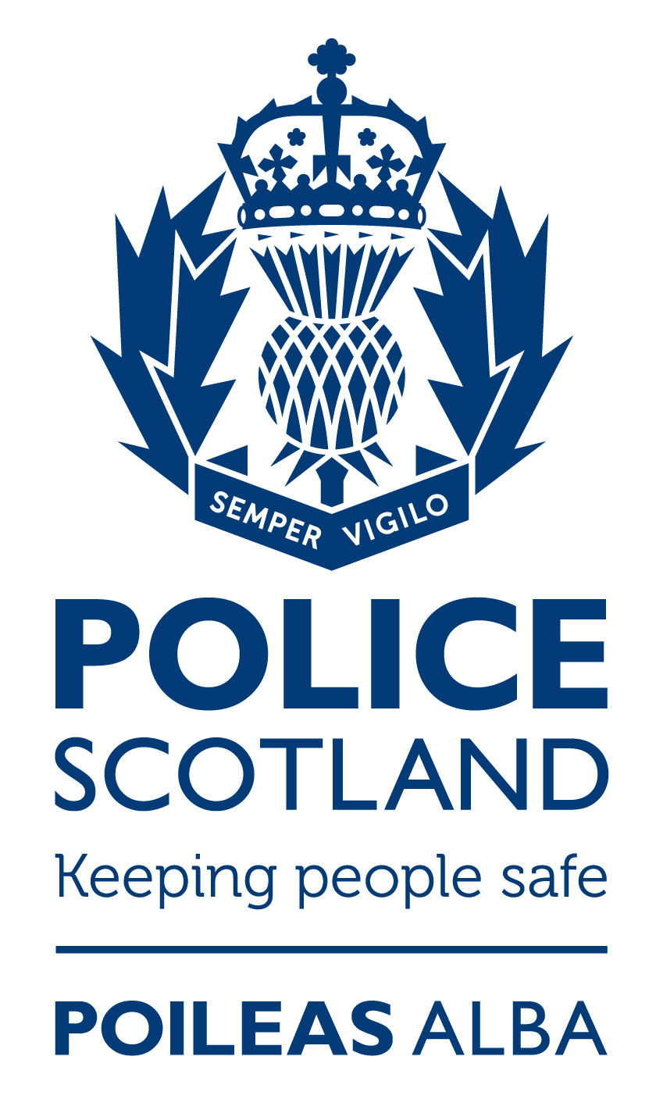
It’s everyone’s responsibility to keep children safe from harm.

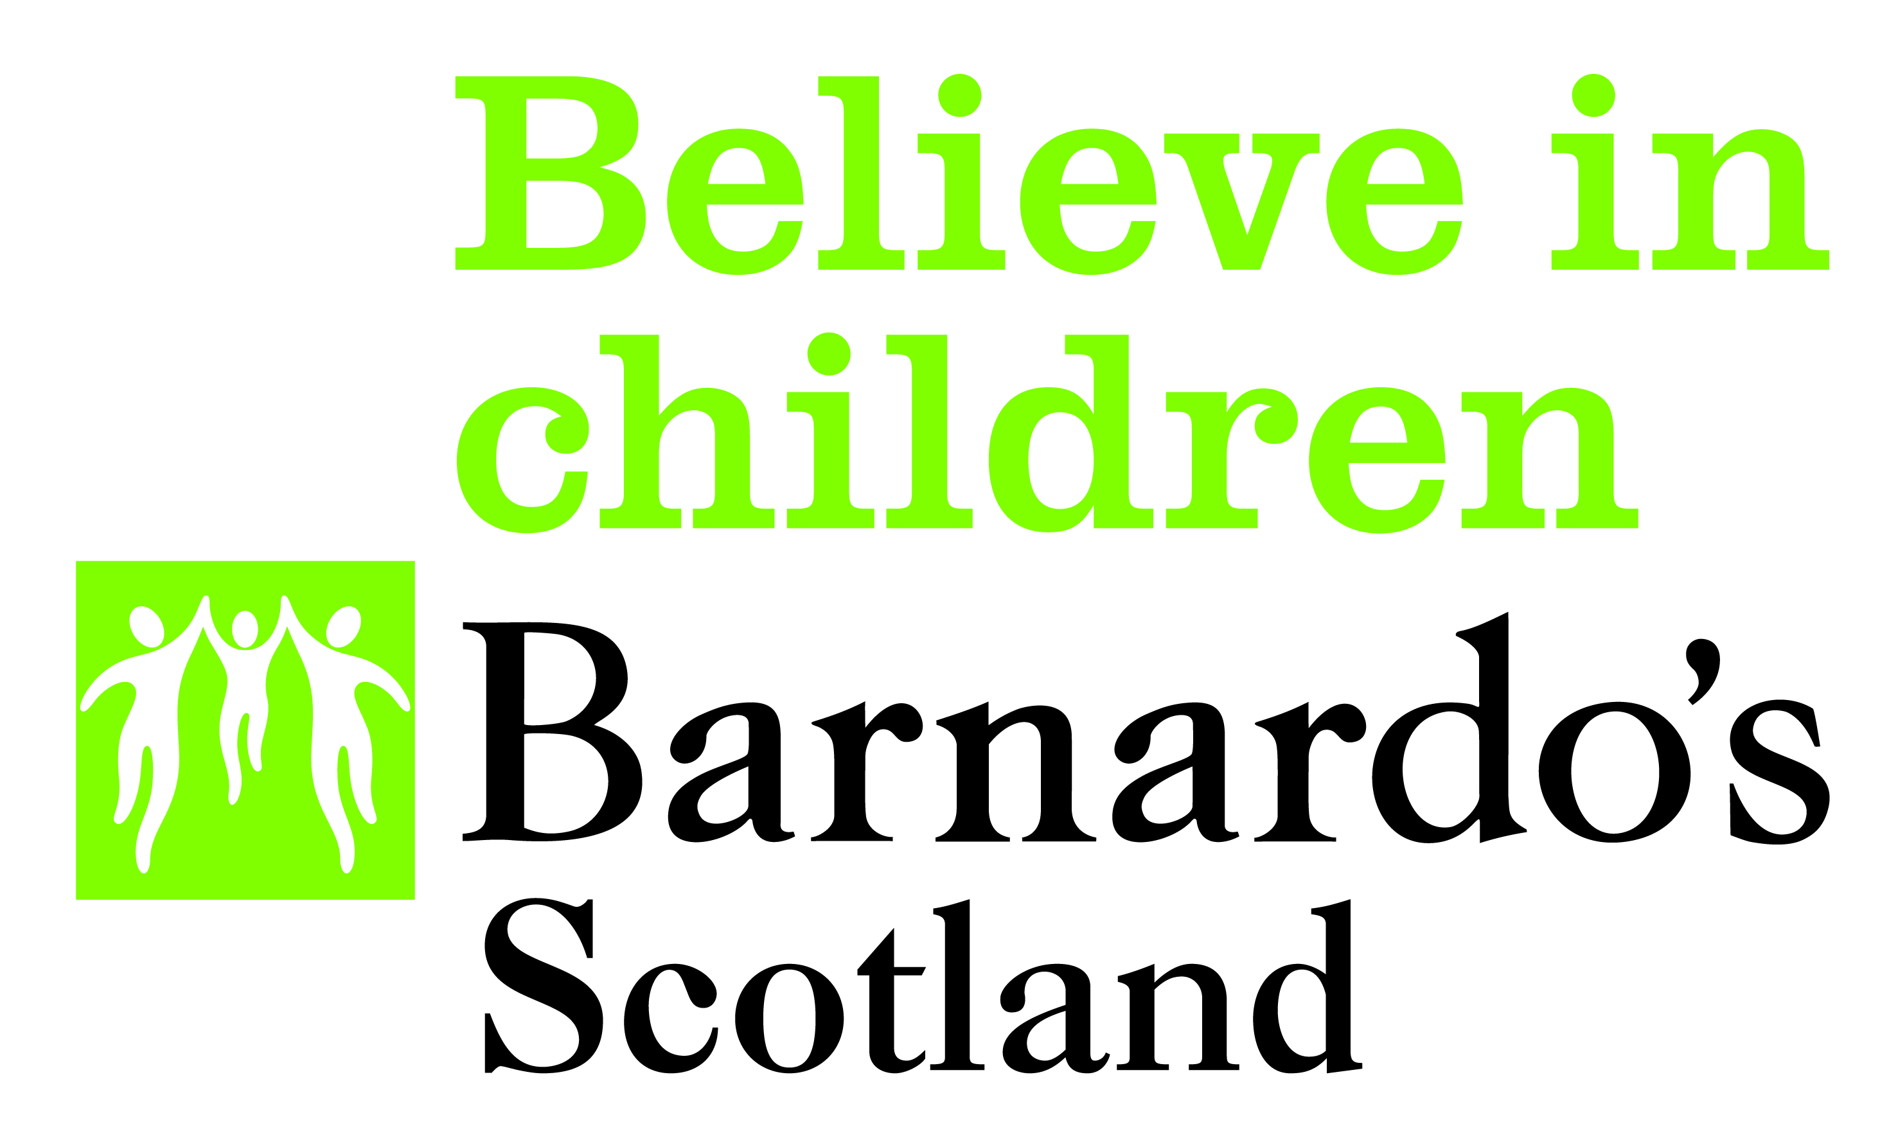
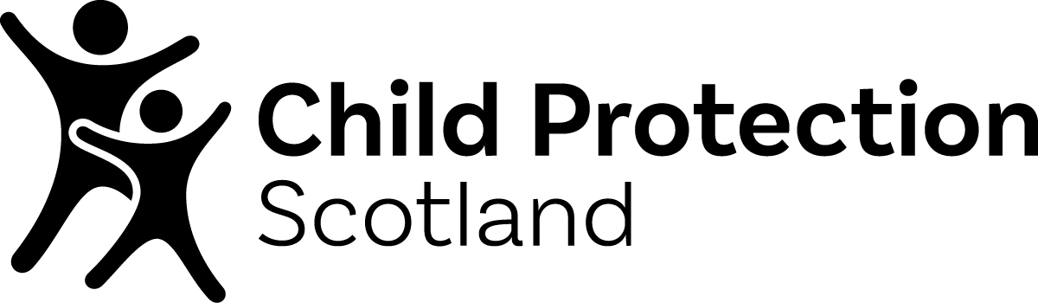

Campaign key messages

  - lockdown has had an effect on every child and every family
  - lockdown was worse/more difficult for some children and families than others
  - some families have been pushed to crisis point by the pandemic/during lockdown
  - even the most settled families and children may have experienced trauma during lockdown in ways that they never will have before
  - some children will have endured neglect or abuse during lockdown
  - trauma and bad experiences can take time to emerge
  - it’s important for everyone to keep an eye out for unusual behaviours or signs that things are not right for a child over the coming weeks and months
  - it is vital that adults let children know they are there for children and young people to talk to and that they will listen
  - it’s important to understand that some behaviours might indicate a problem
  - if a child needs to speak, please listen, but sometimes it’s what’s not said that matters
  - if something’s not right, or you’re worried, it’s important to act on your instincts
  - of a child has been abused or neglected you can help them get the support they need
  - it’s always better to say something than do nothing

#KeepingKidsSafe

NB graphics for use on social media on next pages…

For further information about the campaign or to arrange an interview, please contact:

Mairi Damer, WORD UP Communications
Email: hello@wordupscot.co.uk
Tel: 07809 597901

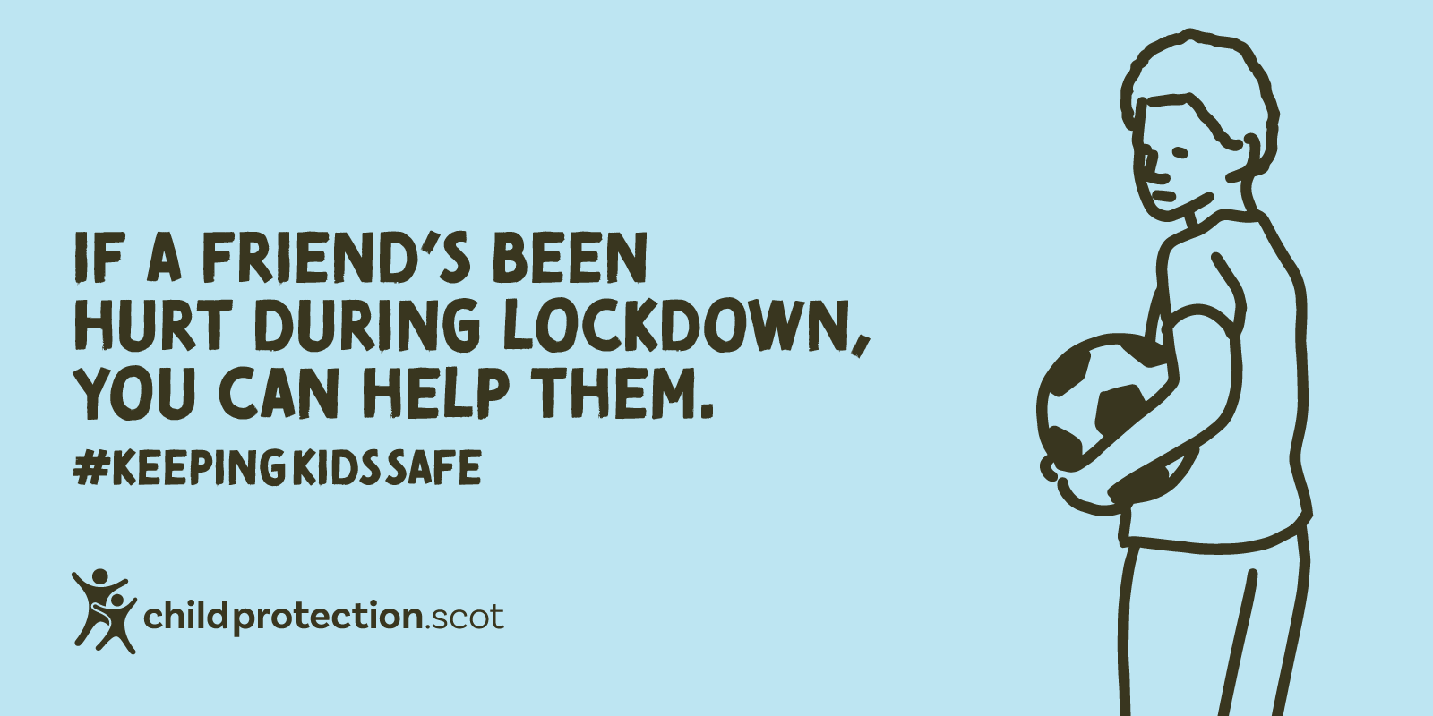
For children

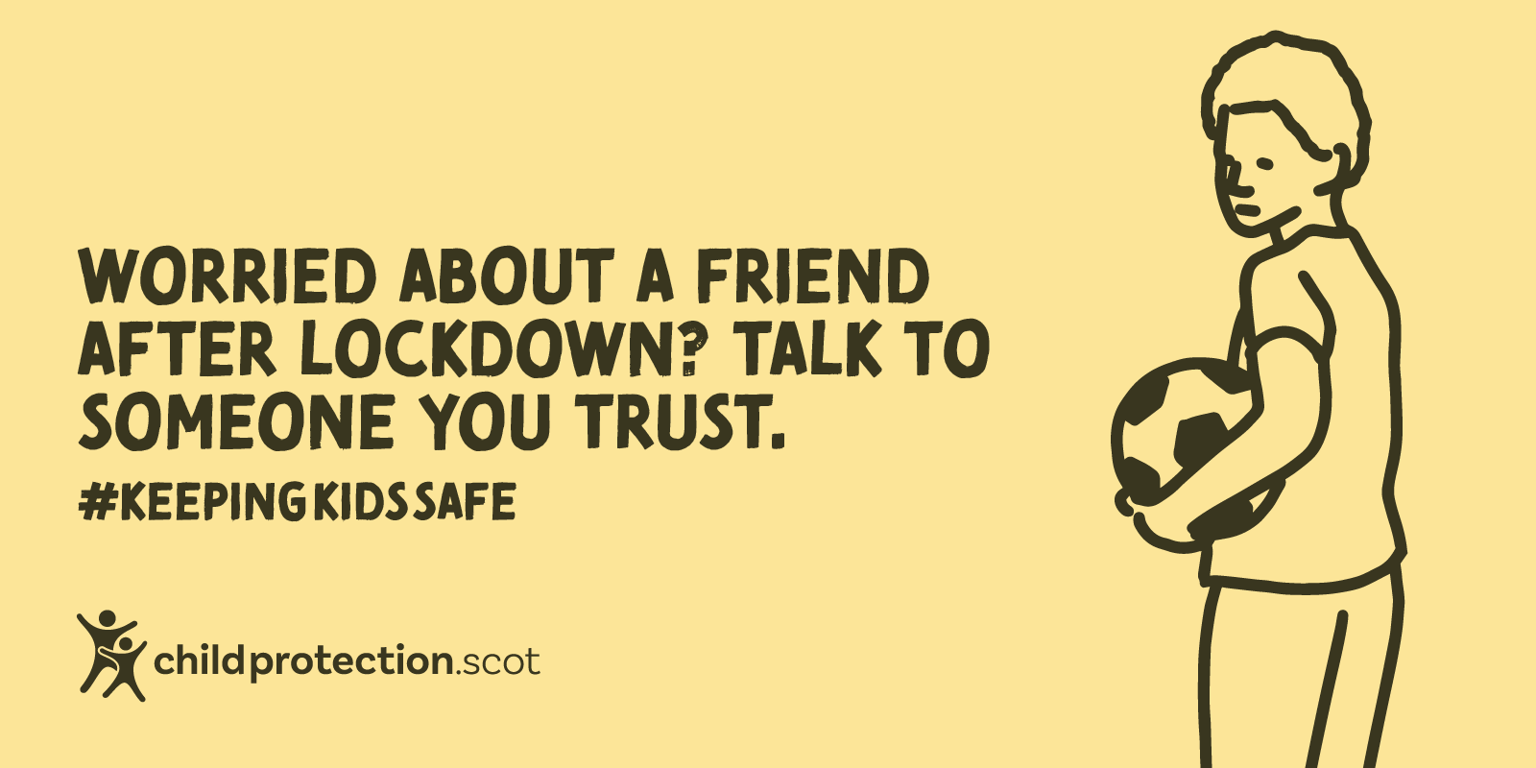
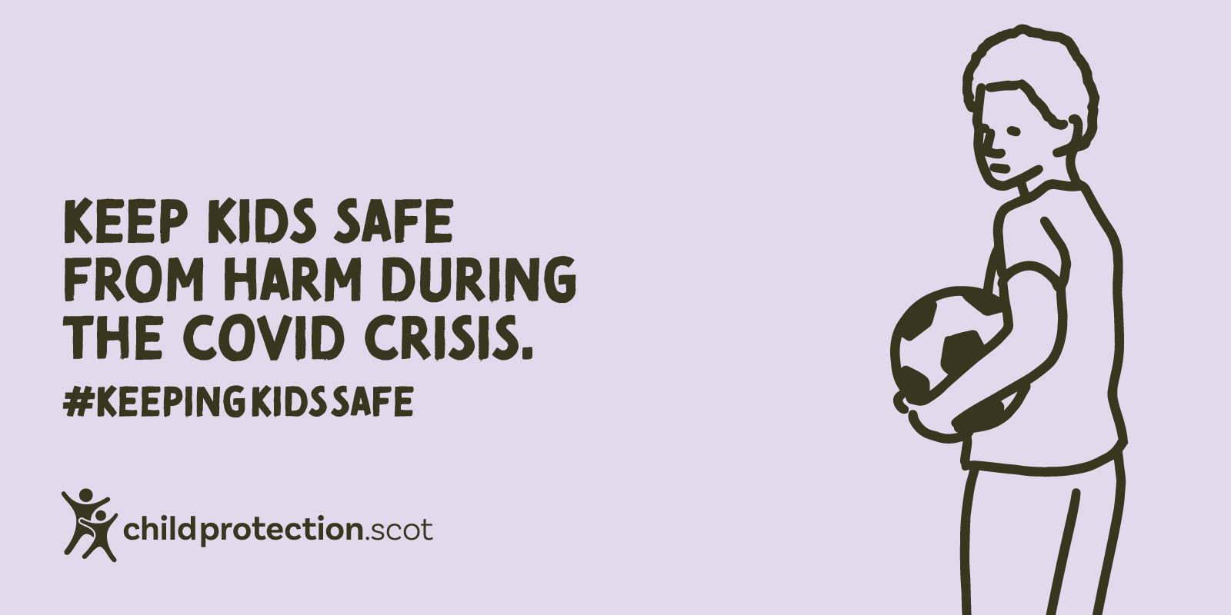

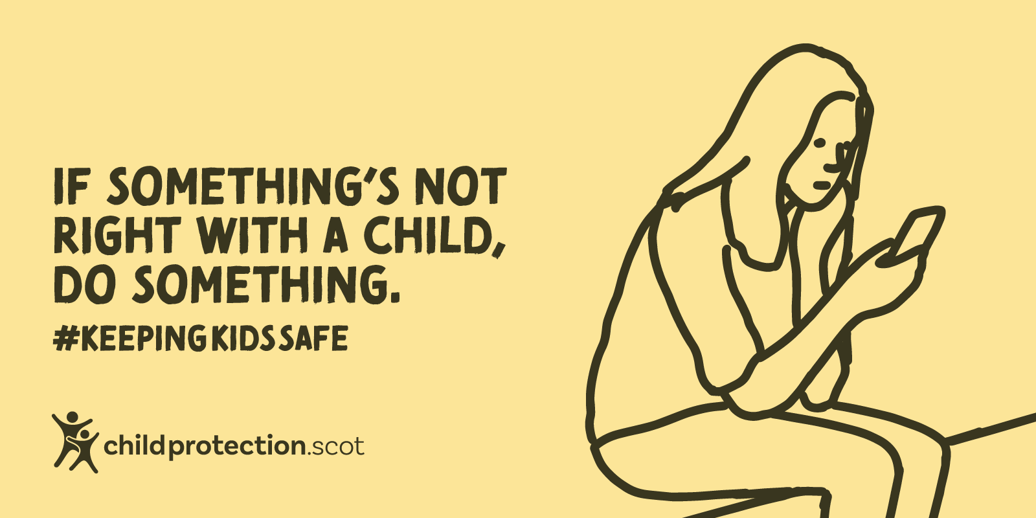
For adults

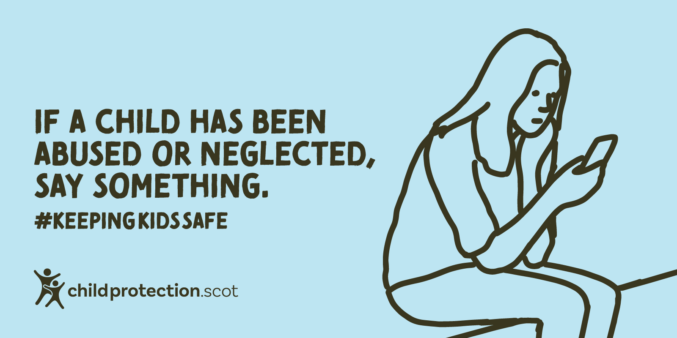

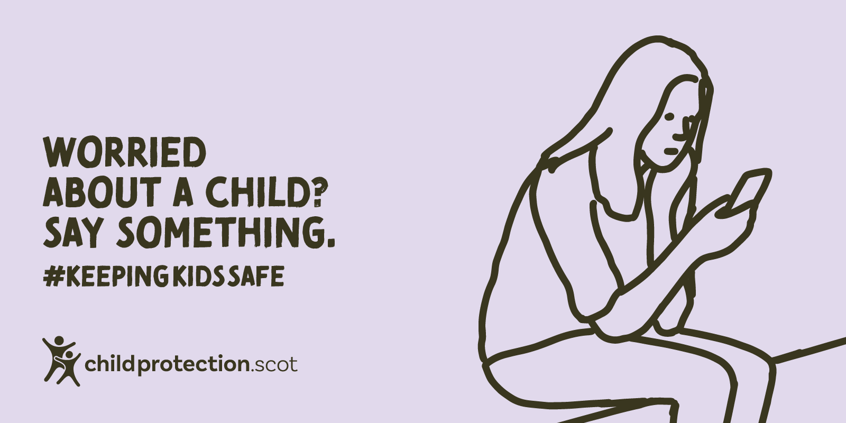

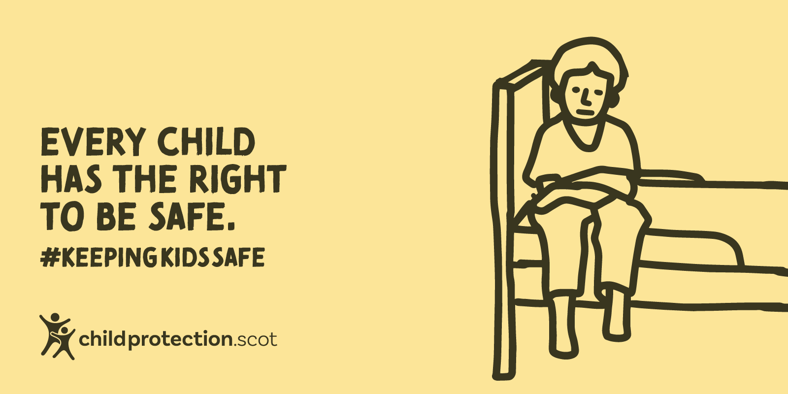
For adults working or volunteering with children

