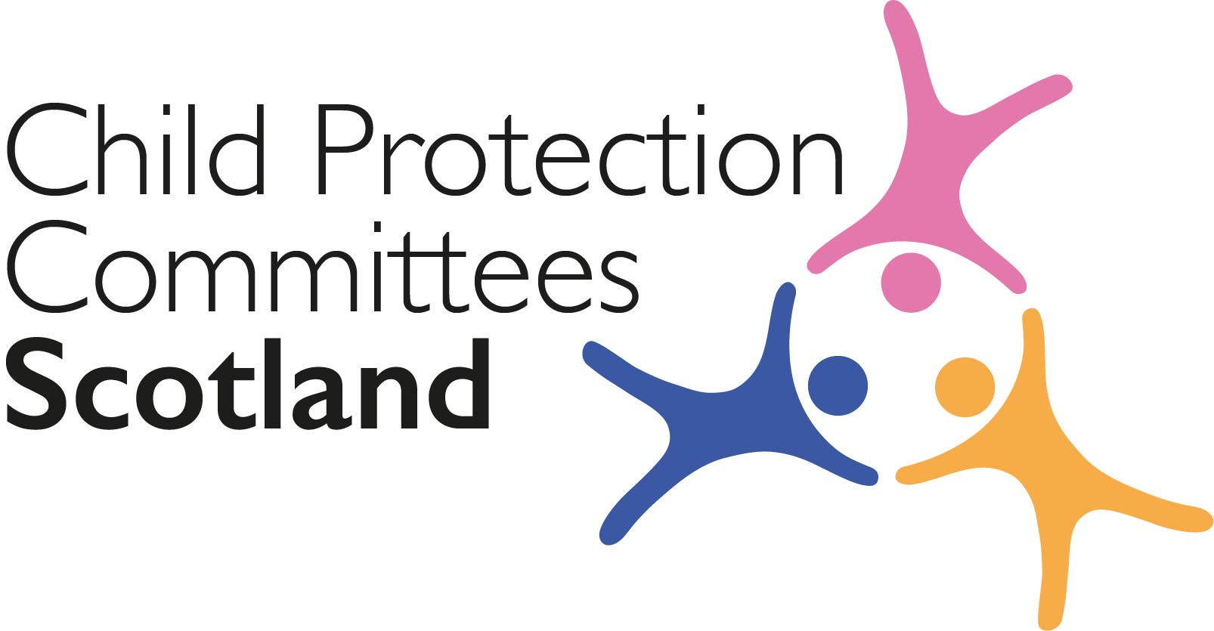
Keeping Connected - The CPCScotland Weekly Bulletin
Issue 37 - Tuesday 8th December 2020

Issued to support Child Protection Committee’s and partners with up to date information on child protection issues.

Welcome to Issue 37 of Keeping Connected.

This week we have our last CPCScotland meeting of 2020. It has been a year none of us will ever forget. Our weekly Keeping Connected bulletin was introduced to CPC members on 31st March 2020 as a short term response to the need to share key information on COVID-19 with members without bombarding inboxes. It has proved a popular and useful communication tool that has continued to be published every week since. As you know it has now been expanded to include information on other child protection related issues and I know many of you use it as the basis for communications with CPC members and other staff groups. This week’s edition is a little shorter than usual but still includes links to a range of useful information.

Keep safe and keep in touch.

Alan Small, Chair Child Protection Committees Scotland

Section 1 COVID-19

Guidance, Resources and Information

1 Scottish Government Early Learning and Childcare COVID-19 Update No. 9 – November 2020
The Scottish Government has released a new Early Learning and Childcare COVID-19 Update.
https://www.careinspectorate.com/images/documents/coronavirus/Scottish_Government_Early_Learning_and_Childcare_COVID-19_Update_Novemberx.pdf?utm_medium=email&utm_source=govdelivery

2 Cyber Resilience Notice – COVID 19

The latest Cyber Resilience Notice (December 2020) is now available online.
https://cyberscotlandweek.com/news-database/bulletindecember2020
It includes an article on National Cyber Security Centre guidance on safe video conferencing for individuals and organisations.
https://www.ncsc.gov.uk/guidance/video-conferencing-services-using-them-securely
https://www.ncsc.gov.uk/guidance/video-conferencing-services-security-guidance-organisations

Section 2 Other Child Protection Topics

Guidance, Resources and Information

3 Online safety
The UK Safer Internet Centre has published a report analysing data from the Professionals Online Safety Helpline, a national helpline and part of the UK Safer Internet Centre that assists members of the children’s workforce with online safety and safeguarding issues. The report finds that cases involving young people included: 42.86% relating to peer to peer abuse; 18.37% adult abuse; 20.41% inappropriate internet use (including viewing and distributing pornographic, violent or terrorist content): and 10.20% sexting.
https://swgfl.org.uk/assets/documents/uk-safer-internet-helpline-annual-report-1.pdf

Training

4 Co-regulation and Attunement with Vulnerable Children
The Mulberry Bush, a charity providing services to meet the needs of emotionally traumatised children, young people and their families, is hosting an online event on Friday 22 January 2021 on the emotional needs of vulnerable children, including group and panel discussions. There is a cost for this event however with early bird tickets are on sale now.
https://www.eventbrite.co.uk/e/co-regulation-and-attunement-with-vulnerable-children-online-event-tickets-130279468397?mc_eid=2e539ebb95&mc_cid=f249706010

5 Caring for Children Moving Alone: Protecting Unaccompanied and Separated Children

The latest run of this six-week online training course offered by the University of Strathclyde and CELCIS is still open for anyone working in or with an interest in the care and protection needs of unaccompanied and separated children and young people.
https://www.futurelearn.com/courses/caring-for-children-moving-alone

6 Caring for Vulnerable Children – Free online course

This Massive Open Online Course (MOOC) from CELCIS on the approaches involved in caring for vulnerable children is still open for sign-ups. This involves around 4 hours of study per week for 6 weeks. This is ideal for staff wanting an introduction into this subject.
https://www.celcis.org/training-and-events/events-pages/caring-vulnerable-children/

Research and Evidence Based Reports

7 Infants Born into Care in Scotland

The Scottish Centre for Administrative Data Research have recently released a report on Infants Born into Care in Scotland: Initial Findings which looks at patterns of care in the first year of life. This includes tracing the number, rates, placement stability and outcomes for these infants:
https://www.scadr.ac.uk/news-and-events/news-new-report-infants-born-care-scotland

8 Scottish Fuel Poverty Advisory Panel annual report
The Scottish Government has published the second annual report of the Scottish Fuel Poverty Advisory Panel, which also looks at the effects for children of living in a cold home.
https://www.gov.scot/publications/scottish-fuel-poverty-advisory-panel-second-annual-report-2019/
9 Scottish Study of Early Learning and Childcare
The Scottish Government has published the findings from the third and final phase of the Scottish Study of Early Learning and Childcare (SSELC), a research project established to evaluate the expansion of early learning and childcare in Scotland. This research aimed to gather a robust baseline of child and parent outcomes for a representative sample of three-year-old children in their first term of funded early learning and childcare provision. This phase also followed up the same group of eligible two-year-old children from Phase 1 of the study after they had experienced a year of 600 hours of early learning and childcare.
Scottish Study of Early Learning and Childcare

Part 3 News and Opinion

10 In the media

- Figures from the Scottish Government show that in 2019/20, Police Scotland recorded 672 concerns of adults neglecting, mistreating or assaulting children, and the NSPCC has launched a Christmas campaign to remind adults of the signs of abuse after it was found that the charity’s Childline telephone counselling sessions across the UK increased by 22% compared to pre-lockdown levels
https://news.stv.tv/scotland/almost-700-cases-of-child-cruelty-and-neglect-recorded-last-year?top
- A report published by ScotCen, a leading social research organisation, has suggested that the Scottish Government’s landmark national scheme to provide free childcare hours to two-year-olds may actually be preventing some children from getting the learning support and care they need due to limitations in the criteria used to assess eligibility https://www.heraldscotland.com/news/18923899.free-childcare-needy-children-may-missing-landmark-scheme/

11 Self-Isolation Support Grant

Scottish Social Security Secretary Shirley-Anne Somerville has announced that the £500 Self-Isolation Support Grant will be extended to include parents on low incomes whose children are asked to self-isolate: https://www.gov.scot/news/more-people-can-claim-self-isolation-support-grant/

12 Winter support fund for families and children
The Scottish Government has announced the ‘Winter Plan for Social Protection’, a £100 million support package designed to help those on low incomes, children and people at risk of homelessness or social isolation cope with winter weather and the economic impact of COVID-19 and Brexit.
https://www.gov.scot/news/winter-support-fund-for-families-and-children/

13 Children’s Experience of Bereavement

New research published by the University of Strathclyde has revealed that more than half of Scottish children have experienced the bereavement of a close family member by the age of eight, and that the risk of children from deprived households experiencing the death of a parent was five times more likely
https://www.strath.ac.uk/whystrathclyde/news/studyrevealsmorethanhalfscottishchildrenexperiencebereavementbytheageofeight/

14 Coronavirus: Christmas anxiety
Action for Children has released findings from an online survey of 1,060 parents of children aged 18 and under, and 1,031 children aged 6-15 looking at their views about Christmas during the coronavirus pandemic. Findings include: 17% of parents said they would cancel Christmas this year if they could and 57% of UK children think their parents will be worried about making it a happy time for their family. The poll also looks at the mental health toll the crisis has taken on children and finds that 49% reported anxiety; 38% said they were scared of getting ill or dying and 33% felt lonely.
https://www.actionforchildren.org.uk/media-centre/millions-parents-say-theyd-cancel-christmas-if-they-could/

15 Poverty
The Child Poverty Action Group has released figures which show that, before the coronavirus pandemic, 1.3million school-age children who lived below the UK’s poverty line were not entitled to free school meals. Analysis found that: 1.2m children in England below the poverty line are ineligible for free school meals; 45,000 in Scotland, 70,000 in Wales and 20,000 in Northern Ireland. These children are in families in low paid work but do not qualify because of eligibility criteria. CPAG estimates that another 100,000 school children across the UK (who are not covered by universal infant free school meals) are in families with no recourse to public funds because of their immigration status.
https://cpag.org.uk/news-blogs/news-listings/two-five-uk-children-under-poverty-line-are-not-eligible-free-school-meals

Please feel free to let us know what you think about the bulletin and provide information for inclusion in future editions. Please contact Alan Small or Susan Mitchell at cpcscotland-liaison@strath.ac.uk. Please note that the information included in this bulletin is provided in good faith. Inclusion does not indicate CPCScotland endorsement of the content of the linked documents or websites.

