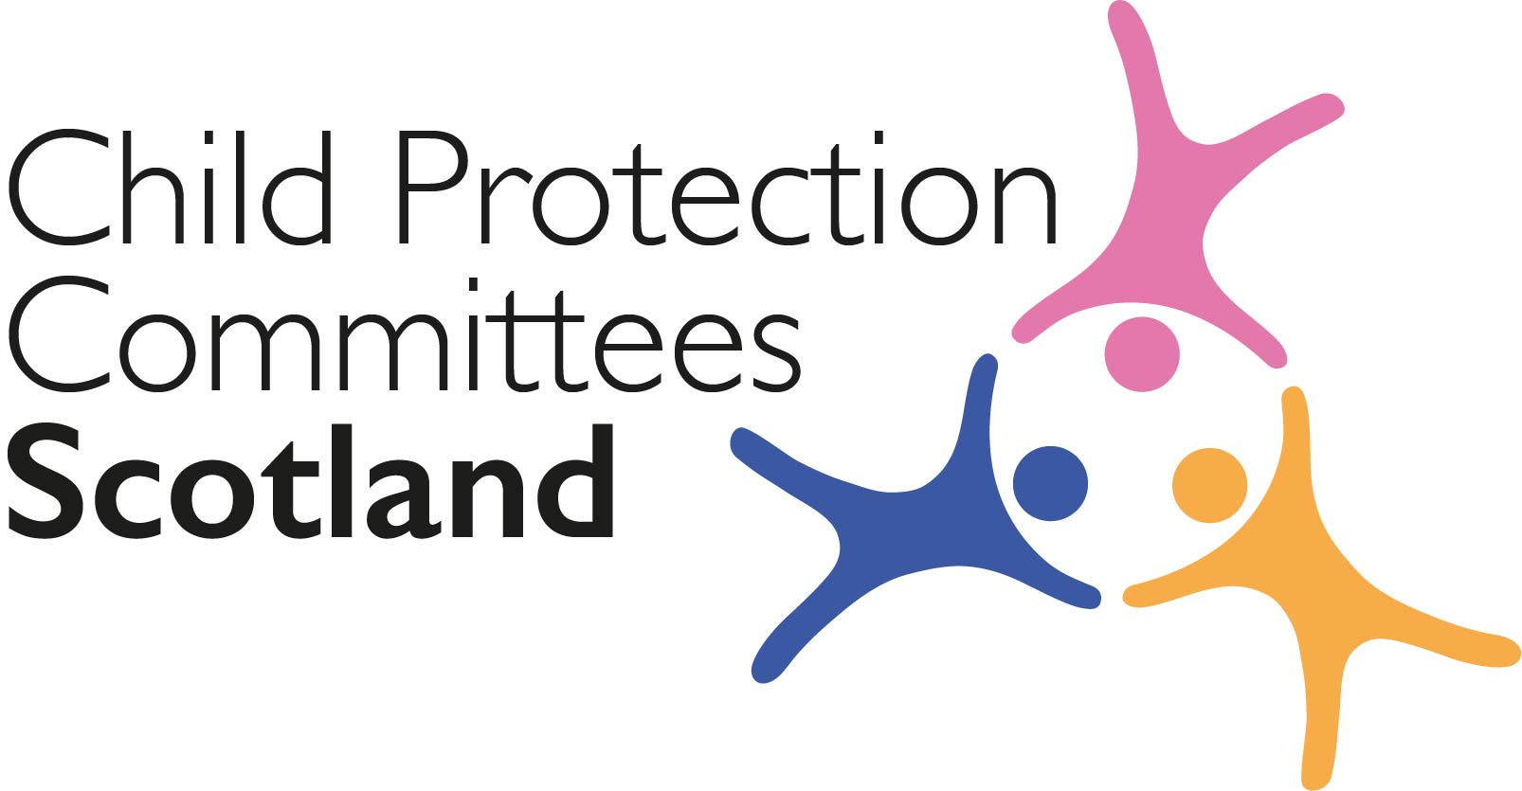
Keeping Connected - The CPCScotland Weekly Bulletin
Issue 28 - Tuesday 6th October 2020

Issued to support Child Protection Committee’s and partners with up to date information on child protection issues.

Welcome to Issue 28 of Keeping Connected.

I hope you are well.

It has been a busy week for Child Protection Scotland. On Wednesday 30th September we held our third virtual meeting of the network. In a jam-packed meeting we heard from the author of the draft National Guidance for Undertaking Learning Reviews and members of the writing group on the key components of the guidance and how we can contribute to finalising the document. In the second half of the meeting, there was an update on progress and future plans for the roll out of the National Joint Investigative Interviewing Project and we were brought up to date on developments around implementing Barnahus in Scotland.

On Thursday 1st October we hosted our second online learning event through the Learning Review Knowledge Hub which focussed on a thematic review on working with young people with sexually harmful behaviour. I am reliably informed this generated a lot of interesting debate and discussion and I look forward to the next event. Added to this our digital campaign entered it’s third week with promising signs of engagement from the general public.

Keeping Connected this week includes a link to young people’s own voices about how they feel emerging from lockdown and going back to school with the latest edition of the Children’s Parliament Corona Times Journal. If anyone has any local examples of how you are hearing children’s voices we would love to feature these in a future edition of the bulletin.

Keep safe and keep in touch.

Alan Small, Chair Child Protection Committees Scotland

Stop Press:-

Physical punishment and discipline of children: how the law is changing

Scottish Government have today published an online factsheet in advance of the change in the law, which will apply from 7th November. Further advice is expected within the next week or so.

https://www.gov.scot/publications/physical-punishment-and-discipline-of-children-how-the-law-is-changing/

Section 1 COVID-19

Guidance, Resources and Information

1 Corona Times Journal ‘Return to School’

The Children’s Parliament has published number 6 in the series of the Corona Times Journal, with children reporting on the return to school. The Journal will be of interest to school staff, support agencies, parents and carers. It can also be shared with children to prompt and support them to reflect on their own views and experiences.
https://www.childrensparliament.org.uk/childrens-journal-6/

2 Infographic of Covid related children and young people related data

The Scottish Government’s Education Recovery Group has published a series of infographics giving a weekly snapshot of current COVID-related data in relation to children and young people, and their associated workforce, such as the number of tests and positive cases reported, and the attendance and absence of both children and staff in childcare and school settings: https://www.gov.scot/publications/covid-19-education-recovery-group-children-and-young-people-infographic/

3 Poverty in Scotland 2020

The Joseph Rowntree Foundation (JRF) has published ‘Poverty in Scotland 2020 – the independent annual report’, a briefing which looks at what has happened to poverty in Scotland before and during the coronavirus outbreak
https://www.jrf.org.uk/report/poverty-scotland-2020

4 Child Poverty Action Group (CPAG) Resources

CPAG in Scotland has a range of briefings and factsheets to help workers advise and support care-experienced young people, kinship carers and others.
They have recently produced ‘Coronavirus and benefits for kinship carers in Scotland’ and ‘Coronavirus and benefits for care-experienced young people in Scotland’ explaining some of the social security implications for kinship carers and care-experience young people of the current coronavirus pandemic.
https://askcpag.org.uk/content/202271/coronavirus-and-benefits-for-kinship-carers-in-scotland
https://askcpag.org.uk/content/203293/coronavirus-and-benefits-for-care-experienced-young-people-in-scotland

5 Childhood in the time of COVID

The Children’s Commissioner for England has publishing report examining the impact of the Covid-19 crisis on children. The report, ‘Childhood in the time of Covid’, calls for a comprehensive recovery package for children and provides a roadmap for what should be done to help children to recover from their experiences of the last six months and the ongoing crisis.
https://www.childrenscommissioner.gov.uk/2020/09/29/a-comprehensive-recovery-package-is-needed-to-tackle-rising-tide-of-childhood-vulnerability-caused-by-the-covid-crisis/

6 CELCIS coronavirus resource page
The CELCIS coronavirus information online resource rounds up key information, advice and guidance that is specifically supporting the care and protection of children and young people in Scotland during the coronavirus pandemic: https://www.celcis.org/covid19info/

7 Cyber Resilience Notice – COVID 19

The latest Cyber Resilience Notice (October 2020) along with all previous issues is available online.
https://blogs.gov.scot/cyber-resilience/2020/05/06/cyber-resilience-notice-covid-19/

This month’s edition includes an article on Online Gaming with links to
- Get Smart About PLAY
The UK Interactive Entertainment Association (UKIE) campaign, which includes easy guides for parents and carers to set controls on most of the popular gaming consoles.
https://www.askaboutgames.com/get-smart-about-play
- Online gaming for families and individuals
National Cyber Security Centre’s guidance on how to enjoy online gaming securely
https://www.ncsc.gov.uk/guidance/online-gaming-for-families-and-individuals

8 Adult protection

Information on adult protection during COVID-19 can be found on the National APC Co-ordinator’s website
https://napc.scot/

For Children, Families and Communities

9 How are you doing? survey deadline extended

In response to requests from colleagues in Education the Children’s Parliament have extended the deadline for their national survey for 8 to 14 year olds until Friday 9th October: The survey takes just 5 to 7 minutes to complete. If you can use your own networks in any way to let people know about the new closing date that would be much appreciated. Children can also complete it at home with the support of parents or carers.
https://www.childrensparliament.org.uk/our-work/children-and-coronavirus/

As part of the Back to School resource the Children’s Parliament have published a Lesson Plan that can be used to help children learn about surveys as a tool, and then introduces the How are you doing? survey itself.
https://backtoschoolscot.files.wordpress.com/2020/09/how-are-you-doing_-wellbeing-survey.pdf

10 Anxiety related absence

Enquire in partnership with the National Autism Implementation Team (NAIT) Scotland have published the first in a new series of infographics titled “Talking to your child’s school about….”. The first one looks at the issue of anxiety related absence and has eleven handy tips to help parents and carers talk to their child’s school about this.
https://enquire.org.uk/publications/talking-to-your-child-about-anxiety-related-absence/

Research and Evidence Based Reports

11 Living through a lockdown

Three violence prevention charities in England, StreetDoctors, Redthread and MAC-UK have published a report following a survey of young people at risk of serious violence to find out how lockdown affected their lives and their communities. Findings from analysis of 41 responses from young people aged between 14 and 25 include: 66% said their feelings of safety either did not change or they felt less safe during lockdown, and 76% reported a negative impact on their mental health.
Living through a lockdown: reflections and recommendations from young people at risk of serious violence (PDF)
Section 2 Other Child Protection Topics

Guidance, Resources and Information

12 Child Trafficking Activity

‘Project Aidant’ is part of a European initiative, led in the UK by the National Crime Agency. An ‘intensification period’ runs from 5th – 9th October 2020 which will involve co-ordinated activity to enhance and develop knowledge in relation to child trafficking and exploitation of under 18s. One of the specific objectives is to ‘Raise awareness of child trafficking amongst local communities and galvanise local partners to undertake coordinated activity’. Watch out for activity in your local area.

13 Sexting

NSPCC Learning has updated its content on sexting advice for professionals which covers: policies and procedures; what to do if you are concerned a sexting incident has taken place; reporting concerns and getting images removed from the internet; and raising awareness about sexting.
https://learning.nspcc.org.uk/research-resources/briefings/sexting-advice-professionals
14 Sexual Abuse Online Resources
The Marie Collins Foundation (MCF) and the NWG Network have published resources for professionals and for parents and carers working with issues of online sexual harm and young people. The guidance contains information about what online harm is, the specific issues facing young people, and ways professionals, parents and carers can engage with and support young people.
https://www.mariecollinsfoundation.org.uk/assets/news_entry_featured_image/NWG-MCF-Professionals-Leaflet.pdf
https://www.mariecollinsfoundation.org.uk/assets/news_entry_featured_image/NWG-MCF-Parents-Leaflet.pdf

15 Suicide Prevention Guidance (England)

Public Health England has published guidance for local authorities in England on how to develop a suicide prevention strategy and action plan. The guidance outlines priorities for short-term action, which includes the mental health of children and young people.

https://www.gov.uk/government/publications/suicide-prevention-developing-a-local-action-plan
Training

16 Safe & Together

Information about all Safe & Together training can be accessed online. Some courses are available free of charge however for other courses a charge applies.
https://safeandtogetherinstitute.com/events-main/
Research and Evidence Based Reports

17 Scottish Health Survey results published
The Scottish Government’s Chief Statistician has published the Scottish Health Survey 2019, providing information on the health, and factors relating to health, of adults and children in Scotland. This includes the first estimate of the national prevalence of Adverse Childhood Experiences (ACEs) in adults - in 2019, 15% of adults reported having experienced four or more ACEs and those in the most deprived areas were almost twice as likely as those in the least deprived areas to have experienced four or more ACEs.
https://www.gov.scot/collections/scottish-health-survey/

18 Rescue and Response County Lines Project

This strategic assessment provides a detailed report on a project supporting young Londoners affected by county lines exploitation. https://www.london.gov.uk/sites/default/files/rescue_recovery_year_2_sa_-_sept_2020.pdf

19 Fetal Alcohol Spectrum Disorder

Within their annual report ‘Adoption Barometer: A stocktake of adoption in the UK’, Adoption UK has published an ‘in focus’ section on Fetal Alcohol Spectrum Disorder (FASD). This describes on the findings from a survey of almost 5,000 adoptive parents across the UK, of which 8% knew that their child had foetal alcohol spectrum disorder (FASD), and a further 17% suspected this was the case. For parents whose child has FASD: 55% of children waited two years or longer for their FASD diagnosis; 78% of parents whose children were diagnosed with FASD did not feel that healthcare professionals were knowledgeable about the condition; and 70% of parents whose children were diagnosed with FASD felt that their child’s school did not understand the condition.
https://www.adoptionuk.org/Handlers/Download.ashx?IDMF=c79a0e7d-1899-4b0f-ab96-783b4f678c9a

Part 3 News and Opinion

20 In the media

- Parents and childcare businesses are calling for the Scottish Government to relax COVID-19 limits to activities such as mother and toddler groups and other children’s activities as they are concerned that children and their caregivers are missing out on vital interaction: https://www.bbc.co.uk/news/uk-scotland-highlands-islands-54370266
- Whilst giving evidence to the Scottish Child Abuse Inquiry last week, organisations have apologised for their part in child migration schemes sending children to Commonwealth countries: https://www.sundaypost.com/news/scottish-news/organisations-apologise-for-soul-destroying-child-migration-schemes/

21 A step closer to tackling poverty

The Social Security Administration and Tribunal Membership (Scotland) Bill has been passed by the Scottish Parliament – the Bill supports the delivery of the new Scottish Child Payment, to provide low-income families with an additional £10 per week, initially for each child aged under six: https://www.gov.scot/news/a-step-closer-to-tackling-poverty/

22 How to win the Wild West Web

In a new report, ‘How to win the Wild West Web – Six tests for delivering the online harms bill’, NSPCC has laid out six tests the Online Harms Bill, the UK Government’s regulation of social media, will be judged on if it is to achieve lasting protections for children online: https://www.heraldscotland.com/news/18757454.moves-criminal-sanctions-social-media-firms-online-sex-crimes-scots-children-surpass-five-day/

23 Children & Young People’s Mental Health Coalition (CYPMHC) annual report

This report finds that children are at risk of worsening mental health from a combination of the coronavirus pandemic and rising poverty and inequality. It calls for a cross government approach to put the health of children and young people at the heart of decision making; and a moratorium on school exclusions over the next academic year so that pupils have the time to adapt to changes.
https://cypmhc.org.uk/wp-content/uploads/2020/09/CYPMHC_AnnualReport.pdf

Please feel free to let us know what you think about the bulletin and provide information for inclusion in future editions. Please contact Alan Small or Susan Mitchell at cpcscotland-liaison@strath.ac.uk. Please note that the information included in this bulletin is provided in good faith. Inclusion does not indicate CPCScotland endorsement of the content of the linked documents or websites.

