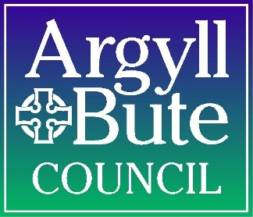

ARGYLL AND BUTE COUNCIL
COMMUNITY COUNCILS
NOTICE OF ELECTIONS

BY-ELECTION DAY – 2 MAY 2024

- By-Elections are to be held for the return of Community Councillors for the Community Councils within the Oban, Lorn and the Isles area of Argyll and Bute.

- Persons wishing to represent their Community Council must be 16 or over on the day of election, reside in the community council area and be named on the elector register for the community council area in which they are standing. A candidate’s proposer and seconder must also be named on the electoral register and reside in the same community council area.

- Nomination papers must be lodged with the Returning Officer, Kilmory Headquarters, Lochgilphead PA31 8RT, by hand, by post, or by emailing elections@argyll-bute.gov.uk on any day except a Saturday or Sunday after the date of this notice, but not later than 4.00pm on THURSDAY 21 MARCH 2024 and withdrawals of persons nominated must be intimated at the same address not later than 4.00pm on THURSDAY 21 MARCH 2024.

- Nomination forms may be obtained from the Returning Officer at the addresses below or can be downloaded from the Council website, www.argyll-bute.gov.uk/elections or by e-mailing elections@argyll-bute.gov.uk.

Argyll and Bute Council
Legal and Regulatory Support
Kilmory Headquarters
Lochgilphead
PA31 8RT

Pippa Milne,
Returning Officer,
Kilmory,
Lochgilphead, PA31 8RT

6 March 2024

