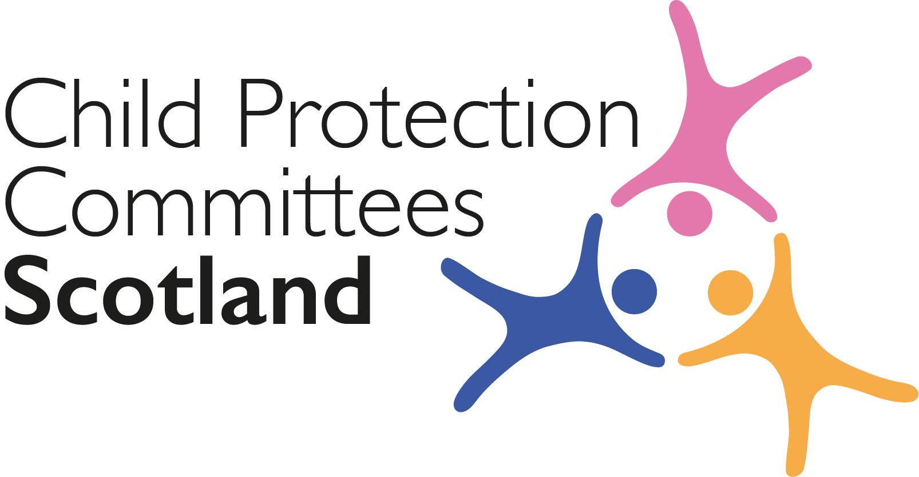
Keeping Connected - The CPCScotland Weekly Bulletin
Issue 34 - Tuesday 17th November 2020

Issued to support Child Protection Committee’s and partners with up to date information on child protection issues.

Welcome to Issue 34 of Keeping Connected.
This week has seen the launch of consultation events in relation to the revised National Guidance for Child Protection in Scotland. CPCScotland were the first grouping to benefit from a session with the new chair of the guidance steering group Professor Brigid Daniel and the guidance team. There are a further 6 sessions planned between now and early December for CPC members and further sector specific sessions planned. It is our intention to submit a CPCScotland response to the consultation which reflects the significance of the guidance revision. I am sure CPCs and associate member networks will also submit their own responses. You can download a word or pdf version of the consultation questions here https://www.gov.scot/publications/consultation-revised-national-guidance-child-protection-scotland-2020/ however you are encouraged to submit your response via the Scottish Government Consultation Hub - https://consult.gov.scot/child-protection/consultation-on-the-revised-national-guidance/. The deadline for responses is 19th January 2021.

Can I also remind you that responses from CPCs and associate members on the consultation on the Learning Review Guidance are due by 25th November 2020. Responses to this consultation should be sent to cpcscotland-liaison@strath.ac.uk

Keep safe and keep in touch.

Alan Small, Chair Child Protection Committees Scotland

Section 1 COVID-19

Guidance, Resources and Information

1 ‘How are you doing?’ national wellbeing survey

Children’s Parliament has published the fourth/final report for 2020 on the results from the ‘How are you doing?’ national wellbeing survey for 8 to 14 year olds. The report compares children’s responses from lockdown to the September/early October period and explore some key questions: What should concern us? Are there signs of recovery?
https://www.childrensparliament.org.uk/wp-content/uploads/How-are-you-doing_Survey_Final.pdf

2 Get Help or Get Caught

‘Get help or Get Caught’ is Police Scotland’s Online Child sexual abuse (CSA) campaign. Following the roll out of the first phase of the campaign on 14 April, 2020 Police Scotland have decided to re-run this campaign for a period of 16 weeks starting from 16 November, 2020. They have produced a partners toolkit (attached) which contains information which will assist if you are able to help spread the campaign messages. It includes:
- Information about the campaign
- Key messages
- Planned communications methods
- Campaign assets you can use
- Useful contacts

3 Cyber Resilience Notice – COVID 19

The latest Cyber Resilience Notice (November 2020) is available online.
https://cyberscotlandweek.com/news-database/bulletinnovember2020
Previous issues can be viewed here:-
https://blogs.gov.scot/cyber-resilience/2020/05/06/cyber-resilience-notice-covid-19/

4 Inspecting services for children and young people

The Care Inspectorate suspended their normal inspection programme for registered care services for children and young people in March in response to Scottish Government national restrictions on movement put in place to help suppress the spread of COVID-19. They have now revised and restarted their inspection programme. Services included in this programme are care homes for children, school care accommodation services (both mainstream and residential), secure care, fostering and adoption, and some support and housing support services. However, this does not include childminders or daycare of children.

5 Care Inspectorate Compendium Guide

The Care Inspectorate have recently updated the compendium guide - Guide to Covid-19 Information (Updated 6 November 2020). The guide links to a range of information that you may find useful.
https://www.careinspectorate.com/images/documents/coronavirus/Covid_19_Guidance_Compendium_06.11.20.pdf

6 Updated ELC, childminding and school-aged childcare guidance

The Scottish government has updated COVID-19 guidance for Early Learning and Child Care, Childminding and school aged children childcare services:
- https://www.gov.scot/publications/coronavirus-covid-19-early-learning-and-childcare-services/?utm_medium=email&utm_source=govdelivery
- https://www.gov.scot/publications/coronavirus-covid-19-school-age-childcare-services/?utm_medium=email&utm_source=govdelivery

https://www.gov.scot/publications/coronavirus-covid-19-childminder-services-guidance/?utm_medium=email&utm_source=govdelivery

7 Coronavirus (CPVID-19) organised activities for children
The Scottish Government has published guidance for the safe running of organised activities indoors and outdoors provided for children and young people. This guidance is for organised unregulated activities and services provided indoors and outdoors for children and young people, including babies and toddlers, that are voluntary, third sector, parent or peer led or unregulated providers delivering a service or activity directly to children under 18.
https://www.gov.scot/publications/coronavirus-covid-19-organised-activities-for-children/

8 ELC COVID-19 Update for November 2020

The Scottish Government has published the Early Learning and Childcare Covid-19 Update for November. This update contains information on the local protection levels set for each local authority area across Scotland and what they mean for the childcare sector.
https://www.careinspectorate.com/images/documents/coronavirus/Scottish_Government_Early_Learning_and_Childcare_COVID-19_Update_October.pdf?utm_medium=email&utm_source=govdelivery

9 Coronavirus: research database
UNICEF has produced the Children and COVID-19 Research Library database to highlight the available global scientific research and evidence on children and the coronavirus pandemic. Key topics on the database include child poverty, education, mental health, social protection and child well-being.
https://www.unicef-irc.org/covid-children-library

Research and Evidence Based Reports

10 15 Stories

Family life matters, and the impact of the Covid-19 pandemic on families must be understood if we are to ensure best efforts for recovery and make rights real for children. Children’s Parliament has published 15 stories from parents, carers and children that capture experiences of the past tumultuous months from lockdown to the return to nursery/school.
https://15stories.scot/

11 Child protection and social distancing: Improving the capacity of social workers to keep children safe during the COVID-19 pandemic

The University of Birmingham has published new research on improving the capacity of social workers to keep children safe during the COVID-19 pandemic, which found that the risks to professionals are not being evenly spread. https://www.birmingham.ac.uk/schools/social-policy/departments/social-work-social-care/research/child-protection-and-social-distancing.aspx

12 How Societal Responses to COVID-19 Could Contribute to Child Neglect

This Canadian study examined parents’ reports on the response their children received to their needs during the COVID-19 crisis. The researchers concluded that ‘during the COVID-19 pandemic, societies made choices to protect their citizens from the virus. These decisions could have created contexts of child neglect. With the closure of services and institutions, and the isolation of families from communities, as well as formal and informal social supports, many children experienced unmet needs. Whereas part of this response was justified by the unprecedented spread and the many unknowns about the virus, certain decisions did not consider meeting the needs of children a priority. Societies must learn from this crisis to put children at the top of their priorities in the face of a societal crisis. Thoughtful discussions and energy must be given to ensure that, while facing a crisis, the developmental trajectories of children are not sacrificed.’
https://www.careknowledge.com/media/48371/1-s20-s0145213420304166-main.pdf

Section 2 Other Child Protection Topics
Guidance, Resources and Information

13 Homelessness statistics (Young People)

As part of the national release of Scotland’s homelessness statistics for 2019-2020 (published in August 2020), the Scottish Government has published additional statistical tables showing over 7,300 young people under 24 years of age registered as homelessness, over 800 of whom had been looked after by a local authority.
https://www.gov.scot/publications/youth-homelessness-statistics-2019-to-2020/

14 Anti-Bullying toolkit
NSPCC Scotland and respectme, Scotland’s anti-bullying service, have launched ‘Think b4 you type’, a toolkit to help schools in Scotland run campaigns to prevent online bullying. The toolkit was designed in collaboration with young people and it allows young people to design and lead their own campaign around the issue of online bullying and how best to prevent and respond to it.
https://respectme.org.uk/wp-content/uploads/2020/10/TBYT-Toolkit-final.pdf
15 Quality framework for secure accommodation services

The Care Inspectorate have published a new quality framework to drive forward improvements in young people’s outcomes in secure accommodation services. The framework reflect the rights based, person-led and outcome-focussed approach of both Scotland’s Health and Social Care Standards and the new Secure Care Pathway and Standards.
https://www.careinspectorate.com/index.php/news/5876-quality-framework-for-secure-accommodation-services?utm_medium=email&utm_source=govdelivery

16 Composite Stories from the Care Review

The Care Review have published a series of 12 animated videos showing composite stories which present key learning from talking to children, young people and their families and carers.
https://www.youtube.com/watch?v=fxzRgrhJy9c&list=PL9bf9r_G2EsQ3ruLZYCgbPcVJsxHsRI3P

17 Local campaigns to support communities

NSPCC Learning has published content looking at the NSPCC’s work with communities across the UK to develop and deliver local campaigns and initiatives that help protect children and young people from abuse and neglect. The webpage includes examples of NSPCC partnership work in communities and a list of local professionals, agencies and organisations they have partnered with.
https://learning.nspcc.org.uk/services/local-campaigns

18 World Children’s Day

World Children’s Day, UNICEF’s annual day of action for children, takes place on 20 November 2020. The six-point call for action includes a call to governments to support and protect the mental health of children and young people and bring an end to abuse, gender-based violence, and neglect in childhood.
https://www.unicef.org/world-childrens-day ​​​​​​

Research and Evidence Based Reports

19 Young people & parents’ views on privacy and how this affects their participation in the Children’s Hearings System

The Scottish Children’s Reporter Administration (SCRA) has published the findings of new research on young people and parents’ views on privacy and confidentiality in Children’s Hearings, carried out by advocacy charity Who Cares? Scotland.
https://www.whocaresscotland.org/wp-content/uploads/2020/11/Who-Cares-Scotland-privacy-research-policy-briefing.pdf

20 The Cost of a Child in 2020

The ninth annual report in the series from the Child Poverty Action Group on the cost of raising a child.
https://www.careknowledge.com/media/48449/costofachild2020_web.pdf

21 Potential Impediments to the Recognition of the Sexual Exploitation of Young Males Under 18

This briefing paper from the Safeguarding Board for Northern Ireland is based on learning arising from the research on potential impediments to recognising the sexual exploitation of young males (Montgomery-Devlin, 2019). It summarises key themes emerging from the study and associated literature review, including findings related to stereotypical assumptions, criminality, perpetrator gender and paramilitarism. The paper concludes with recommendations to inform CSE policy and practice, specifically with regards boys and young men.
https://www.careknowledge.com/media/48394/briefing-paper-no-1-potential-impediments-to-the-recognition-of-the-sexual-exploitation-of-young-males-under-18.pdf

22 Children living in households with parental vulnerabilities

The Office for National Statistics (ONS) has published a report using data from the Crime Survey for England and Wales to estimate the numbers of children living in households where adult domestic abuse, mental ill-health or substance misuse may be present. ONS estimates that 751,000 (19.3%) children aged 10 to 15 years were living with an adult who reported one of the above in the previous 12 months.
https://www.ons.gov.uk/peoplepopulationandcommunity/crimeandjustice/bulletins/childhoodvulnerabilitytovictimisationinenglandandwales/yearendingmarch2017toyearendingmarch2019
ONS have also published a linked blog ‘How the ONS crime figures help us to better understand the risks to children’
https://blog.ons.gov.uk/2020/11/05/how-the-ons-crime-figures-help-us-to-better-understand-the-risks-to-children/
23 The Use of New Psychoactive Substances (NPS) in Young People and Its Association with Mental Health Issues

This research paper presents the findings of a systematic review of New Psychoactive Substances effects on young people's mental health. The researchers conclude that NPS consumption poses serious health risks, due to both a range of unpredictable clinical pharmacological properties and the typical concomitant use of other psychoactive molecules.
https://www.careknowledge.com/media/48426/nps_and_young_people_accepted_author_version.pdf

24 Technology-assisted child sexual abuse
NSPCC Learning has published an evaluation of InCtrl, a service designed to help keep children aged 9 to 13 years-old safe online to prevent technology-assisted child sexual abuse (TA-CSA). Findings from an evaluation of a pilot of the service between January 2019 and February 2020 include: InCtrl was well-received by the young people attending and practitioners facilitating the groups; and there was evidence of increased digital resilience, emotional resilience, and wellbeing for children who completed the pilot service.
https://learning.nspcc.org.uk/research-resources/2020/implementation-evaluation-of-inctrl

25 VoCO (Verification of Children Online) Phase 2 report
The Department for Digital, Culture, Media & Sport (DCMS), Government Communications Headquarters (GCHQ), and the Home Office have published a report on the Verification of Children Online (VoCO), a child online safety research project that responds to the challenge of knowing which online users are children. The report looks at the issue of age assurance and points out that children’s online safety and wellbeing will be improved if we have an internet that actively recognises children and adapts the spaces they use to make them safer by design.
https://www.gov.uk/government/publications/voco-verification-of-children-online-phase-2-report
Part 3 News and Opinion

26 In the media

- After conducting 900 visits to schools and social care settings since schools fully reopened in England in September, Ofsted has flagged that the children who have been hardest hit by COVID-19 measures are regressing and struggling mentally, with some younger children forgetting basic skills such as using a knife and fork and some older children losing physical fitness and reading and writing skills: https://www.theguardian.com/education/2020/nov/10/children-regressing-and-struggling-mentally-in-lockdown-says-ofsted

- Children’s charity NSPCC Scotland has called for stricter legislation for online child grooming and child abuse after figures from a new Police Scotland taskforce set up to tackle abuse and exploitation of youngsters showed that online grooming crimes have risen by 30% while children were at home during the pandemic: https://www.heraldscotland.com/news/18864328.charity-demands-tougher-laws-online-child-grooming-child-abuse-scotland-soars-lockdown/

- The Scottish Government is facing increased pressure to remove the requirement, under the Redress for Survivors (Historical Child Abuse in Care) (Scotland) Bill, for survivors of historical child abuse in care to sign a waiver giving up their right to take civil action against the institution where they suffered before they can receive financial compensation: https://www.thenational.scot/news/18872123.john-swinney-urged-axe-rule-abuse-survivors-sign-waiver-get-payout/

- Stop It Now are reporting a significant increase in the number of people seeking help for sexual thoughts about children.
https://www.bbc.co.uk/news/amp/uk-52883373?__twitter_impression=true

27 Babies in lockdown: ‘perfect storm’ caused by withdrawal of key services

Early findings from an online survey by the First 1001 Days movement, an alliance of organisations from the children, family, mental health, maternity and baby sectors, suggest that that the redeployment of health visitors, reduction in contacts with families by many services, and the shift to digital and telephone service delivery – where babies are often invisible – all hampered the ability of services to protect the youngest and most vulnerable members of society during the COVID-19 public health emergency: https://www.nurseryworld.co.uk/news/article/babies-in-lockdown-perfect-storm-caused-by-withdrawal-of-key-services

28 Scottish Government Funding to reduce childhood obesity

The Scottish Government has announced more than £600,000 worth of funding for projects working with families to encourage healthy eating and good nutrition, as part of its ambition to halve childhood obesity by 2030. https://www.gov.scot/news/preventing-obesity-in-early-years/

Please feel free to let us know what you think about the bulletin and provide information for inclusion in future editions. Please contact Alan Small or Susan Mitchell at cpcscotland-liaison@strath.ac.uk. Please note that the information included in this bulletin is provided in good faith. Inclusion does not indicate CPCScotland endorsement of the content of the linked documents or websites.

